Evolution: Speciation 5/10/12
I. Defining a species
A. A species is _______________________________________________________________________
B. A hybrid is _______________________________________________________________________
II. Biological species concept
Problems with species definition above:

- _________________________________________________________________________

- __________________________________________________________________________

- __________________________________________________________________________

- __________________________________________________________________________

- __________________________________________________________________________

III. Defining speciation
A. Speciation is ______________________________________________________________________
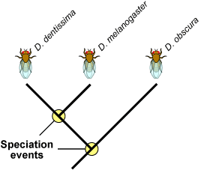
- Speciation example
1. The scene: _______________________________________________________________
2. Disaster: ________________________________________________________________
3. Populations Diverge: ______________________________________________________
4. So We Meet Again: _______________________________________________________
IV. Causes of speciation
A. Geographic isolation: _______________________________________________________________

- Reduction of Gene Flow: ___________________________________________________________

- Reproductive Isolation: _____________________________________________________________
D. Examples:
1. __________________________________________________________________________
2. __________________________________________________________________________
3. __________________________________________________________________________
V. Evidence for speciation
A. Iguanas: ________________________________________________________________________
B. Geographic Patterns: ______________________________________________________________
C. Experimental Results: _____________________________________________________________
VI. Cospeciation
A. Definition: _______________________________________________________________________
B. Example: ________________________________________________________________________
VII. Types of Speciation
Type of Speciation | What Happens | Example
Allopatric | Geographic isolation | A species is divided by the emergence of a barrier, such as a river.
Peripatric | Allopatric + founder effect (founder effect = individuals in new ecosystem genetically different from original population)
Parapatric |  | Plants of same species growing in different soil types flower at different times.
Sympatric | Reproductive isolation without distance or barrier

