Evolution by Natural Selection: The Basics

Biological evolution: the change in the _________________ of a ___________________ over time.

Observation: ___________________________

Question: ____________________________________________________________________________

Summary of possible logical hypotheses:
Independent Development | Evolution from Common Ancestor

Remember Occam’s Razor / lex parsimoniae: the least complex solution is _____________________________________

Which solution is more parsimonious? (least complex) ______________________________________

Scientific explanations require evidence for a _____________________ by which a given hypothesis might happen.

Kettlewell’s Peppered Moth Experiments

The peppered moth species has two color phenotypes, ____________ and _______________.

Kettlewell released moths in 2 different environments, one was ______________ and dark, the other was unpolluted and _____________.

Which phenotype was more successful in the unpolluted environment? _________________

Which phenotype was more successful in the darker environment? _________________
3 Conditions for natural selection
 | Definition | Example
1.
2.
3.
Natural Selection: the process by which _____________________________ that make it more likely for an organism to

_________________________________________________ become __________________ in a ___________________ over successive generations.

Major Lines of Evidence for Evolution by Natural Selection

1. ______________________________________ 2A. _____________________________________
2B.______________________________________ 2C. _____________________________________
3. ______________________________________

Significance of “Darwin’s” Moth:

Modes of Selection
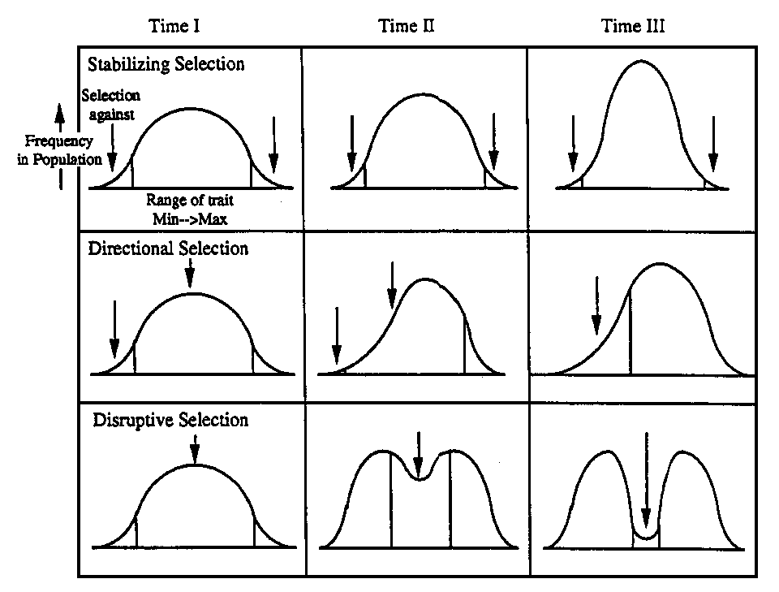

Adaptation (process): the process by which a _________________ of organisms becomes

_________________________________________________________________________ as a result of natural selection

Adaptation (characteristic): a specific feature that makes an organism ________________________________________.

Example: Through the _______________________________, horses developed the ____________________________

for grinding tough plants they eat.

Artificial Selection: _________________________________________________________________________________

