Water Cycle
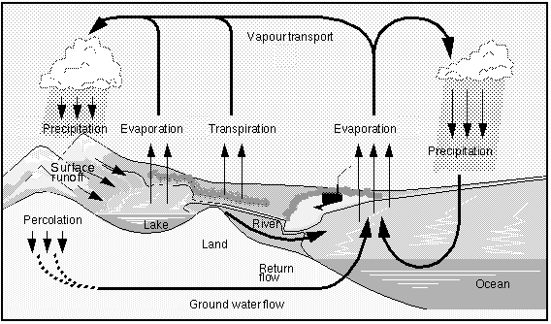
***1. What two processes add water vapor to the atmosphere?

2. What is the only major process that removes water from the atmosphere?

Nitrogen Cycle
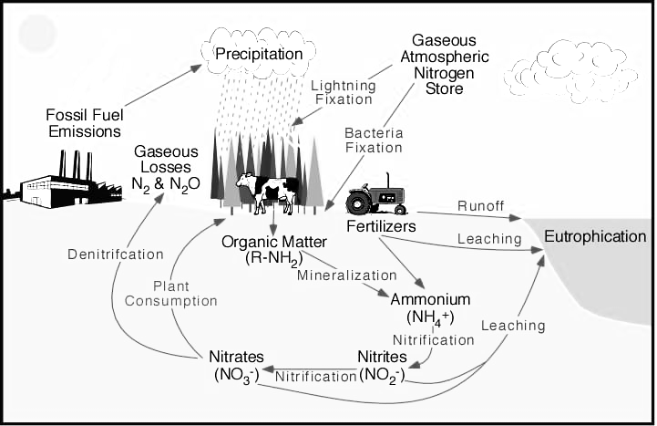
***1. What processes convert nitrogen in the atmosphere into a form most organisms can use?

***2. What type of living organism completes that process?

3. In what 2 ways does human activity affect the nitrogen cycle?

KEY TERMS:

Transpiration:

Nitrogen Fixation:
Eutrophication:

