Biogeochemical Cycles

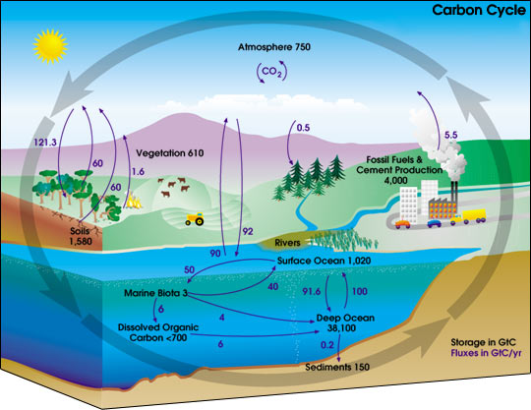
Simple Carbon Cycle:

Scene 1. Where’s the Carbon? Carbon is one of the most abundant elements in the Universe. Where is carbon located on Earth?

1. 5.
2. 6.
3. 7.
4.

Scene 3. Carbon Cycle on Land: (Yes, we skipped scene 2) The carbon cycle on land has a lot to do with plants. Explain what the following processes have to do with the transfer of carbon:

***1. Photosynthesis:

***2. Respiration:

3. Decomposition:

4. Compaction & Transformation:

Scene 5 Human Impact on the Carbon Cycle: Identify and describe the two main impacts humans have on the carbon cycle. How do these activities affect the amount of CO2 in the Earth’s atmosphere?

Carbon in the Atmosphere

1. How are atmospheric CO2 concentrations and global temperature related?

Water Cycle
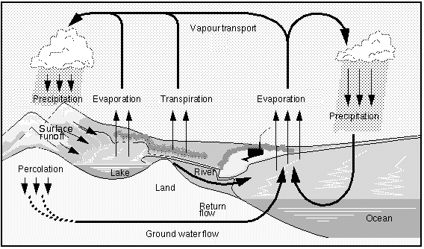
***1. What two processes add water vapor to the atmosphere?

2. What is the only major process that removes water from the atmosphere?

Nitrogen Cycle
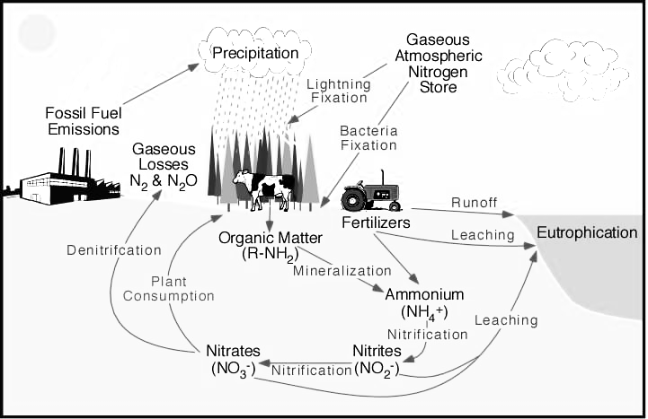
***1. What processes convert nitrogen in the atmosphere into a form most organisms can use?

***2. What type of living organism completes that process?

3. In what 2 ways does human activity affect the nitrogen cycle?

KEY TERMS:

Transpiration:

Nitrogen Fixation

