Populations
Population (definition):

Population size:

Population density:

Population dispersion:

Population Age Distribution:

______________________________________________________________________________Population size example: A microbiologist samples a population of bacteria by counting the number of cells in 1 mL of the liquid they’re in, with the following results
  - Sample 1: 27 individuals
  - Sample 2: 33 individuals
  - Sample 3: 30 individuals
- What is the population size if there are 100 mL of solution all together?

Population Density: D=n/A, where D = ________, n = ________, A = ________

________________________________________________________________

Population Dispersion: ______________________________________________

3 types: ___________________, _________________, __________________

Human population dispersion: __________________

Population Growth Rates (define) __________________________________________________

2 factors that increase population size: ______________, ____________

2 factors that decrease population size: ______________, ____________
______________________________________________________________________________

Population Age Structure

___________ populations grow faster than _________ ones.
______________________________________________________________________________

Growth Curves

Logistical (aka linear or arithmetic) growth: _____________________________

Exponential (aka log) growth: _____________________________

Human population growth before ~1750: ____________ now: _______________

Carrying Capacity: ______________________________________________________________

______________________________________________________________________________

Leibig’s Law of the Minimum: ____________________________________________________

Typical growth curve when a new energy resource is made available: (sketch & label)

______________________________________________________________________________

Survivorship Curves: describe a species strategy for __________________ success:

Curve Type | Number of Offspring | Survival of Young | Example
Type I |  |  | Humans
Type II | Moderate
Type III |  | Low

Name: _____________________________________ Date: _________________ Period: ______

Populations Practice Problems

In the squares below, draw two populations.

Population 1: size = 16 individuals; area = 4 km²; dispersion = even

1. What is the population density of population 1?
Population 1
Population 2

Population 2: density = 2/km², area = 4 km², dispersion = random

2. What is the population size of population 2?

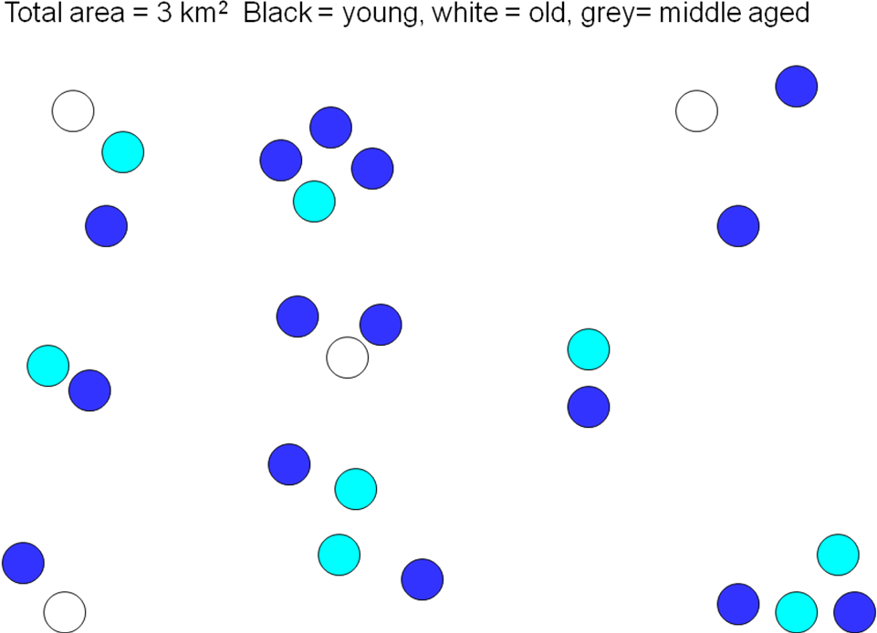
Use the illustration of a population provided to answer the following questions:

3. What is the population size?

4. What is the population density? (area = 3 km²)

5. How is the population dispersed in the area?

6. Age distribution.
A. How many individuals are in each age category?
Young: Middle-aged: Old:

B. Is this a quickly growing population? How do you know?
Comparing Exponential and Linear growth

Part I: Linear vs. Exponential Equations


To understand how much more explosive exponential growth is than linear types, we will compare two curves:

y = X² will represent exponential growth and y = x will represent linear growth.

Use the space at left to graph both equations from x=0 to x=10. Think of the x axis as “time,” or “number of generations,” and the y axis as population size.

Now, compare the y values of the two curves at different x values:

0 1 2 3 4 5 6 7 8 9 10 | Exponential (y=x²) | Linear (y=x)
X=1 | y= | y=
X=3 | y= | y=
X=10 | y= | y=

Part II: Effect of Population Growth on Population Density

Use the data in the table above to see what happens to population density.
Assume these curves refer to a population of rabbits that inhabits a geographical area of roughly 10. km².

Population Density (10 km²)
 | Population Density with Exponential Growth  Y = X² | Population Density with Linear Growth  Y = X
X=1

X=3

X=10

“Compound interest [exponential growth] is the most powerful force in the Universe.” -Albert Einstein (??? Undetermined authenticity)

