Pedigree Basics

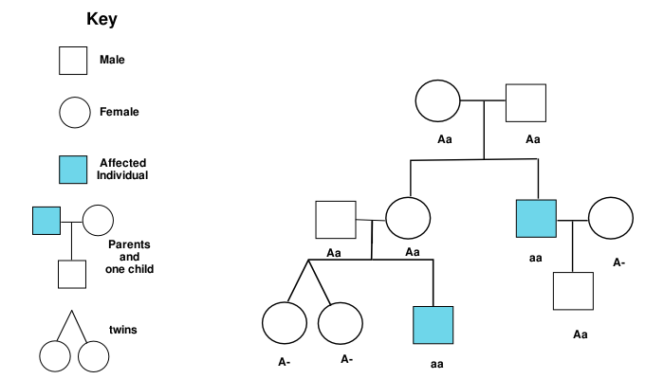

Pedigree analysis

Many traits in humans are controlled by genes. Some of these traits are common features like eye color, straight or curly hair, baldness, attached vs. free ear lobes, the ability to taste certain substances, and even whether you have dry or sticky earwax! Other genes may actually cause disease. Sickle cell anemia, muscular dystrophy, cystic fibrosis are each caused by a specific allele of a human gene, and can therefore be inherited from one generation to the next.
Human geneticists illustrate the inheritance of a gene within a family by using a pedigree chart. On such a chart, males are symbolized by a square (□) and females are symbolized by a circle (○). People who
The pedigree chart below shows inheritance of the gene that causes albinism. A and B represent a couple who had five children, including C and E. Only one of the children, E, was albino. E and her husband had five children, including G.
In the pedigree below write the genotypes of the individuals who are labeled with letters, using (A) to represent the dominant allele and (a) to represent the recessive allele. Start by indicating the genotypes of E and F. Then use a Punnett Square to figure out what the genotypes for C and D must be. Next, determine the genotypes of A and B. Finally, determine the genotype of G.
F
C
D
E
G
A
B
Albino pedigree (read background for more info)

Genotypes:

A. _________ B. _________ C. _________ D. _________ E. _________ F. _________ G. __________

Inheriting Dwarfism

Shown below is a pedigree chart for the inheritance of achondroplasia (ay-kon-druh-play-zhuh), a form of dwarfism. Dark circles or squares indicate individuals with achondroplasia. Examine the pedigree chart, and answer the following questions.

C
D
E
F
G
A
B

1. Using (D) to represent the dominant allele and (d) to represent the recessive allele, write the genotypes of the indicated individuals. For one of the labeled individuals, there are two possible genotypes. Write both genotypes and indicate which one is more likely.

A. _________ B. _________ C. _________ D. _________ E. _________ F. _________ G. __________

2. Based on the frequency of dwarfs among the people you have seen in your lifetime, do you think that the allele for achondroplasia is common or rare in the population?

3. Is the gene that causes this form of dwarfism a recessive or dominant trait? How do you know?

Use the information below to construct a pedigree showing the inheritance of colorblindness in a family. Remember, colorblindness is a sex-linked trait. Use the pedigree you have made to answer the questions that follow

- Jack and Jill are not colorblind.
- They have 4 daughters, April, May, June, and August. None of their daughters is colorblind.
- April marries Larry (who is not colorblind), and they have 3 sons, Larry jr., Mo, and Curly. Mo and Curly are colorblind.
- May does not have any children
- June marries Shemp, and they have 2 daughters and a son, all three of which are colorblind.
- August marries Daffy (who is colorblind), and they have 1 daughter, who is also colorblind.

PEDIGREE

1. Which of Jack and Jill’s daughters (April, May, June, and August) are DEFINITLY carriers for colorblindness?

2. Is Shemp colorblind? How can you be sure?

The Blue People of Troublesome Creek

Six generations after a French orphan named Martin Fugate settled on the banks of eastern Kentucky's Troublesome Creek with his redheaded American bride, his great-great-great great grandson was born in a modern hospital not far from where the creek still runs.
The boy inherited his father's lankiness and his mother's slightly nasal way of speaking.
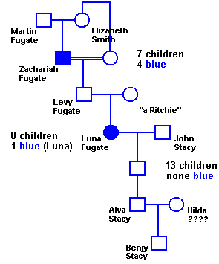
What he got from Martin Fugate was dark blue skin. "It was almost purple," his father recalls.
Doctors were so astonished by the color of Benjy Stacy's skin that they raced him by ambulance from the maternity ward in the hospital near Hazard to a medical clinic in Lexington. Two days of tests produced no explanation for skin the color of a bruised plum.
A transfusion was being prepared when Benjy's grandmother spoke up. "Have you ever heard of the blue Fugates of Troublesome Creek?" she asked the doctors.
"My grandmother Luna on my dad's side was a blue Fugate. It was real bad in her," Alva Stacy, the boy's father, explained. "The doctors finally came to the conclusion that Benjy's color was due to blood inherited from generations back."
Benjy lost his blue tint within a few weeks, and now he is about as normal looking a seven-year-old boy as you could hope to find. His lips and fingernails still turn a shade of purple-blue when he gets cold or angry a quirk that so intrigued medical students after Benjy's birth that they would crowd around the baby and try to make him cry. "Benjy was a pretty big item in the hospital," his mother says with a grin.
Dark blue lips and fingernails are the only traces of Martin Fugate's legacy left in the boy; that, and the recessive gene that has shaded many of the Fugates and their kin blue for the past 162 years.
They're known simply as the "blue people" in the hills and hollows around Troublesome and Ball Creeks. Most lived to their 80s and 90s without serious illness associated with the skin discoloration. For some, though, there was a pain not seen in lab tests. That was the pain of being blue in a world that is mostly shades of white to black.

- Observe the Fugate family pedigree. Do you notice any pattern in the pedigree? (hint: look at gender, number of offspring with the trait, characteristics of the parents and grandparents)

Determine the genotypes of each individual in the pedigree. How is the blue-skin disorder inherited?

  - Do you think that Benjy can have a blue child? Explain.

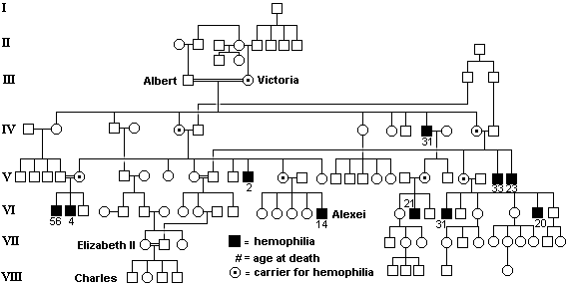
- Now look at the pedigree of the European Royal families showing the distribution of the hemophilia trait. (Note: the Elizabeth labeled is the current Queen Elizabeth of England). Do you notice any pattern in the pedigree? (Hint: it is different from the Fugates, but do look at the same characteristics and pay close attention to the black squares.)

Refer to the two pedigrees to answer the following questions.
  - How are they alike?

  - How are they different?

  - Do you think that any of Queen Elizabeth’s grandchildren will have hemophilia? Explain.

