Genetics: Other Patterns of Heredity

DO NOW (On Screen)

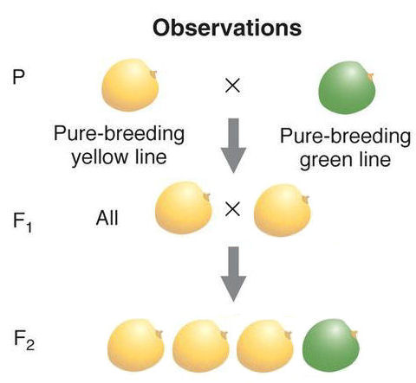

Label the generations of pea plants P, F1, and F2 in the diagram

Codominance: ________________________________________________________________________

Example:

Phenotype ratio: ____________ Genotype Ratio: ___________

Incomplete dominance: ________________________________________________________________

Example:

Phenotype ratio: ____________ Genotype Ratio: ___________

Sex-linkage: ________________________________________________________________________

Example:

Phenotype ratio: ____________ Genotype Ratio: ___________

Multiple Alleles: ______________________________________________________________________

Example:

Phenotype ratio: ____________ Genotype Ratio: ___________

Genetic Crosses: Practice Questions

Directions: ON A SEPARATE SHEET OF PAPER, complete the following problems. For each, show three things: a Punnett square illustrating the cross, the genotype ratio, and the phenotype ratio.

Monohybrid Problems (Complete Dominance)
1. In rabbits the allele for black coat color (B) is dominant over the allele for brown coat color (b). What is the genotypic ratio and phenotypic ratio be for a cross between an animal homozygous for black coat color and one homozygous for brown coat color?
2. White (W) hair in sheep is caused by the dominant gene while black (w) hair is recessive. A heterozygous white male and a black female are parents of a black lamb. What is the probability that their next lamb will be white? What are the genotypic and phenotypic ratios?
Incomplete Dominance Problems
1. Yellow coat color in guinea pigs is produced by the homozygous genotype, YY, and cream color by the heterozygous genotype, Yy. White is produced by the homozygous genotype, yy. What genotypic ratios are produced by matings between cream colored guinea pigs? Describe the phenotypic ratio.
2. In Japanese four o’clock flowers, color is inherited by genes that show incomplete dominance. In such flowers, a cross between a homozygous red flower and a homozygous white flower will always result in pink flowers. Illustrate a cross between 2 pink flowers.
Co-dominance Problems
1. In shorthorn cattle, the hybrid between red and white is roan, having red and white hairs intermingled. If a roan is bred with a white, what will the phenotypic ratio be?
Multiple Allele Problems
1. Suppose a man with homozygous A blood marries a woman with AB blood. What blood types would you expect to find among their children?
2. A man of type AB blood is married to a woman of type O and he questions the legitimacy of her child, who has type O blood. What should the legal judgment be?
SEX! Linkage Problems
- A woman who is a carrier for the colorblindness trait is planning to have a child with a colorblind man. What % of their male children should they expect to be colorblind? What about their female children?

