Karyotype Analysis
BACKGROUND:
Imagine you have just been hired as a genetic counselor whose job is to analyze fetal karyotypes. In this procedure, cells are taken from a developing embryo and they are analyzed to see if the unborn child has any chromosomal mutations. These mutations can have very serious effects, and anxious parents will be waiting to hear your expert results.
KEY VOCABULARY:
Karyotype: A picture of all of the chromosomes found in a cell.
Trisomy: A condition where there are 3 copies of a certain chromosome in the cells of a diploid organism.
Monosomy: A condition where there is only 1 copy of a certain chromosome in the cells of a diploid organism.
Nondisjunction: A type of mutation where homologous chromosomes do not separate during meiosis. This results in gametes that have an extra copy of a chromosome and other gametes that are missing that chromosome.
Nondisjunction:
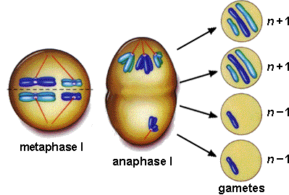

DIRECTIONS: Label each karyotype as one of the following types. The descriptions of the chromosome count are given in the format (total chromosomes, sex chromosomes). For example, a normal female is described as (46,XX) because she has 46 chromosomes total and her sex chromosomes are two Xs. T is the abbreviation for trisomy, and the number after the T indicates which chromosome there is an extra copy of. For example, (47, T-21) means an individual has 47 total chromosomes, including three copies of chromosome number 21.
Normal Male (46,XY)
Normal Female (46,XX)
Down Syndrome (47, T-21)
Patau Syndrome (47, T-13)
Edward’s Syndrome (47,T-18)
Klinfelter Syndrome (47, XXY)
Double Y Syndrome (47, XYY)
Super Female (47, XXX)
Turner’s Syndrome (45, X)

DESCRIPTION: ________________________________
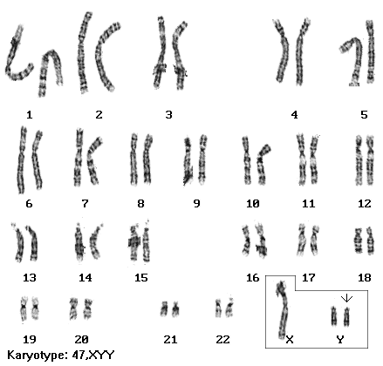

DESCRIPTION: ________________________________
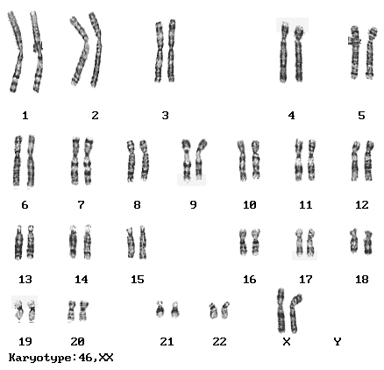

DESCRIPTION: ________________________________
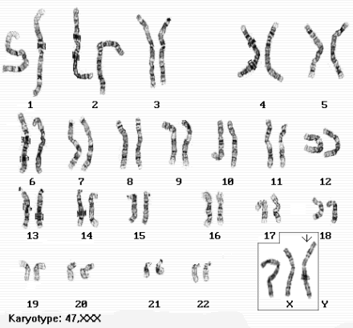

DESCRIPTION: ________________________________
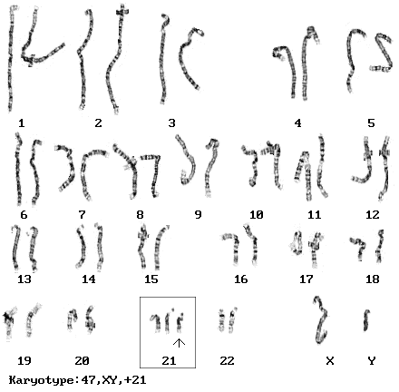

DESCRIPTION: ________________________________
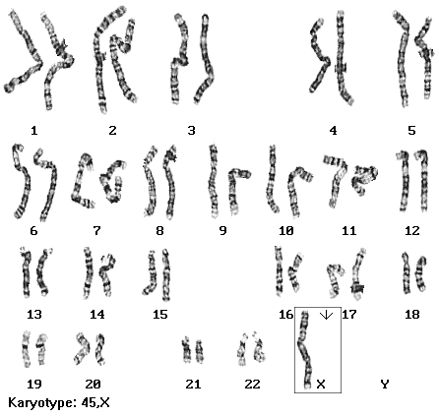

DESCRIPTION: ________________________________
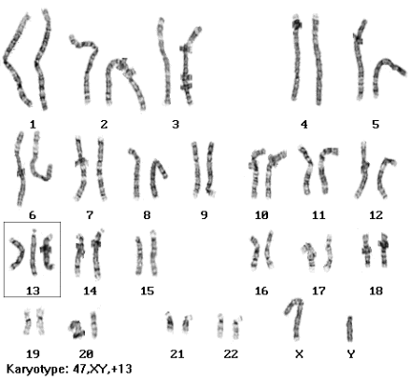

DESCRIPTION: ________________________________
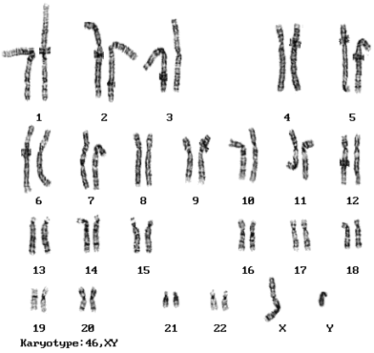

DESCRIPTION: ________________________________
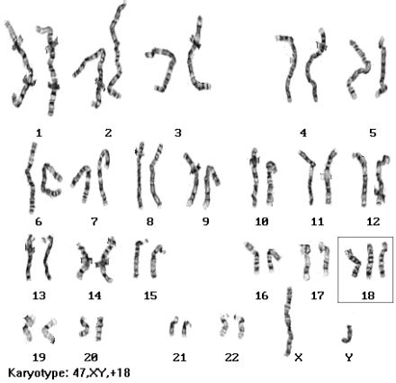

DESCRIPTION: ________________________________
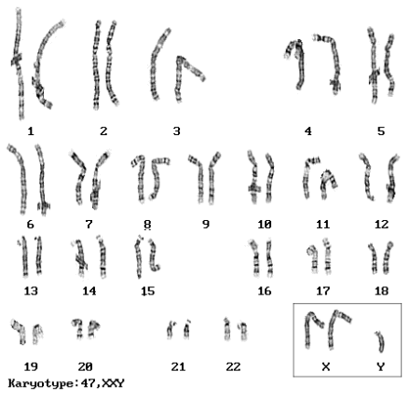
_____________________________________________________________________________________
QUESTIONS: (HINT: Read the background!)
1. How many chromosomes does a typical human cell have? ________
2. What are trisomy and monosomy? _____________________________________________________
_____________________________________________________________________________________
3. What is the name of the process that can cause trisomy or monosomy? ________________________
4. Most embryos that have trisomy do not survive until birth. The three examples of trisomy in this activity are the only known examples where the fetus can survive until birth. What are the three disorders, and which chromosomes are affected?
A. _____________________________________________________________________
B. _____________________________________________________________________
C. _____________________________________________________________________
5. One of the biggest reasons parents have these tests is to determine if an unborn child has one of these serious disorders. If you were an expecting parent, would you want to have a karyotype done or would you rather not want to know? Why?
_____________________________________________________________________________________
_____________________________________________________________________________________
_____________________________________________________________________________________
_____________________________________________________________________________________
_____________________________________________________________________________________

