Chromosomes and EVERYTHING
DO NOW:
- Genes and chromosomes are related because _______________________________________
______________________________________________________________________________.

Chromosomes

Organisms are made of 1 or more __________. Inside of each cell’s nucleus, there are a number of _____________________. These are made up of many different ___________, which determine many of the characteristics of an organism.

When are chromosomes visible in a cell? __________________________________________________.

Chromosome Sketch: In the space below, sketch and label a chromosome that has 2 identical chromatids joined by a centromere. You may use your model as a guide.

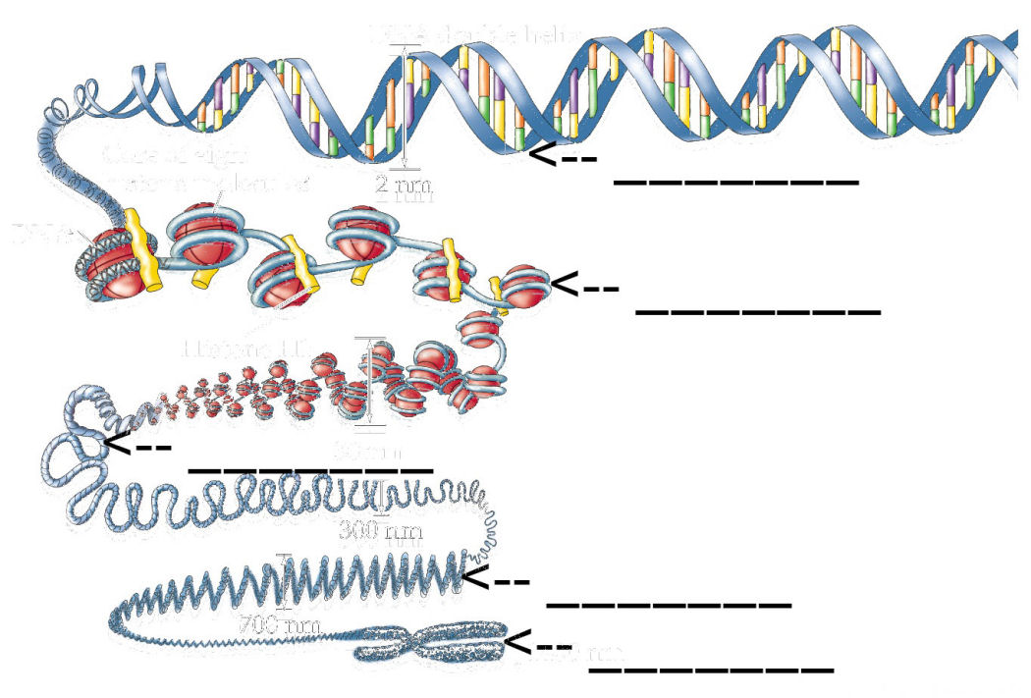

Chromosomes

1. Chromosomes are made of two different types of macromolecules, bundled tightly together: ____________________ and ________________.

2. Histones are ________________ that help _____________________________________.

3. Draw a picture of a single chromosome. Label the sister chromatids and the centromere:

4. Complete the following table about types of chromosomes:
Type of chromosomes |  | Sex chromosomes
Determine gender? | No
Total number in typical human |  | 2
How many came from human male parent? | 22
How many came from human female parent? |  | 1

5. How many chromosomes in total does a typical human have? ______________

6. A horse is a diploid animal, and most of its cells have 62 chromosomes.
A. how many pairs of homologous chromosomes does a horse have? ______
B. What 2 types of horse cells have only 31 chromosomes? ______ and _______

7. Draw a karyotype of a diploid animal that has a 2n chromosome number of 6. Label the homologous chromosomes.

8. What is the difference between sister chromatids and homologous chromosomes?
_____________________________________________________________________________________

_____________________________________________________________________________________

_____________________________________________________________________________________
9. Describe each of the following as haploid or diploid:
A. human skin cell _________________
B. rat sperm cell __________________
C. monkey kidney cell ______________
D. X _____________________________
E. XX ____________________________
F. AbCdE _________________________
G. AabbCCddEe ___________________

10. The sperm cells of a certain species of moth contain 50 chromosomes. How many chromosomes are found in the wing cells of the moth? ___________

11. Prokaryotes contain a single chromosome. Would these cells be haploid or diploid?

12. How many of your cell’s chromosomes are copies of your mother’s? _________

13. When are chromosomes visible in cells viewed with a microscope? __________________________

Vocabulary List: write a brief definition next to each term:

1. autosome: __________________________________________________________________________

2. centromere: ________________________________________________________________________

3. chromatid: _________________________________________________________________________

4. diploid: ____________________________________________________________________________

5. haploid: ___________________________________________________________________________

6. histone: ___________________________________________________________________________

7. homologous chromosomes: ___________________________________________________________

8. karyotype: _________________________________________________________________________

9. sex chromosome: ___________________________________________________________________

10* trisomy: __________________________________________________________________________

Directions: Match the term on the right with the definition given on the left. Each definition will be used once and only once.
1. ____ chromosome | A. A picture arranging chromosomes in pairs from largest to smallest
2. ____ chromatid | B. specialized proteins around which DNA is wrapped in a chromosome
3. ____ centromere | C. equally sized chromosomes that carry the same genetic information
4. ____ karyotype | D. Each chromosome is normally made of 2 of these
5. ____ histone | E. sperm and egg cells are __________
6. ____ autosome | F. chromosomes that have no effect on gender
7. ____ sex chromosome | G. A tightly coiled structure made of DNA and proteins
8. ____ homologous chromosomes | H. A cell that has 2 copies of each chromosome
9. ____ diploid | I. chromosomes that determine the gender of an individual.
10. ____ haploid | J. This structure holds two sister chromatids together

Cell Replication Overview

There are 3 basic types of cellular division. Use the chart below to organize the characteristics of each one.
Type of cell division | Types of cells  that do it | Purpose | Example
Binary fission
Mitosis
Meiosis
For each of the examples below, classify the cell division taking place as binary fission, mitosis, or meiosis.
1. A skin cell divides in order to replace old cells that have died. ________________

2. An E. coli bacterium divides in spoiled potato salad at a picnic. _________________

3. A specialized cell in the ovaries of a woman divide to produce haploid egg cells. _____________

4. A yeast cell buds and produces a new yeast cell that is identical to it. _____________

5. As a puppy grows to become a dog, it’s body cells divide many times. ______________

Illustrate each type of cell division. Make sure your drawing shows how many chromosomes are in the cells before and after they divide.

Initial Cell | Division | Resulting Cells
 | binary fission
 | mitosis
 | meiosis

As instructed in class, construct a foldable notes organizer highlighting the steps of the cell cycle and mitosis. Here’s an overview:

