Introduction to Photosynthesis & Respiration
Do Now:
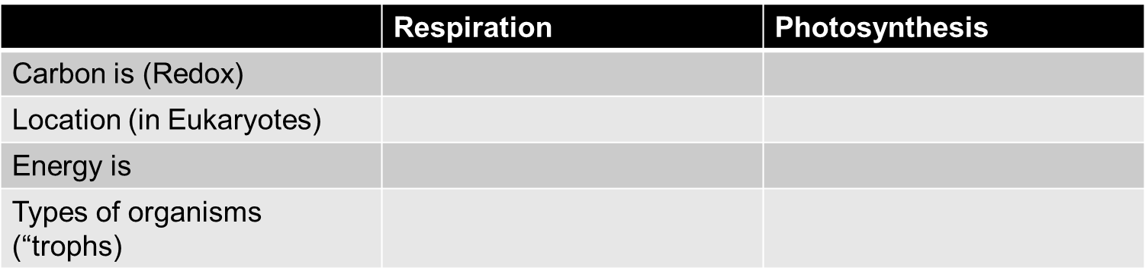
Most autotrophs use the process of ___________________ to capture the energy they need from _________.
Heterotrophs must take in energy from __________________ that they take in.
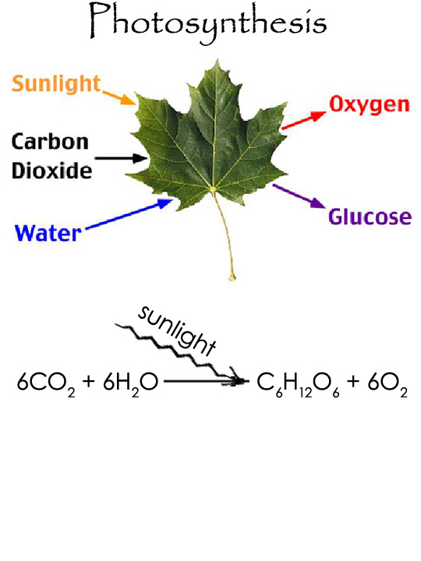
Photosynthesis definition: Photosynthesis uses the energy of _________ to combine _______________ and ___________ to make __________ and ___________
The process of photosynthesis has two main steps:
1. In the ____________________, the energy of light is captured, and ___________ is split into ___ and ___.
2. In the ___________________, CO2 from the ________________ is used to build _______________.
The cell part where photosynthesis takes place in eukaryotic cells is the ____________________.

The Carbon Cycle of Life

The Light Reaction
Labeled Drawing of a chloroplast: label stroma and thylakoids
Big Ideas:
The function of the light reactions is to __________________________________
and store it in chemicals such as ________.
The chemical that captures light is called ____________________.

How the light reactions happen
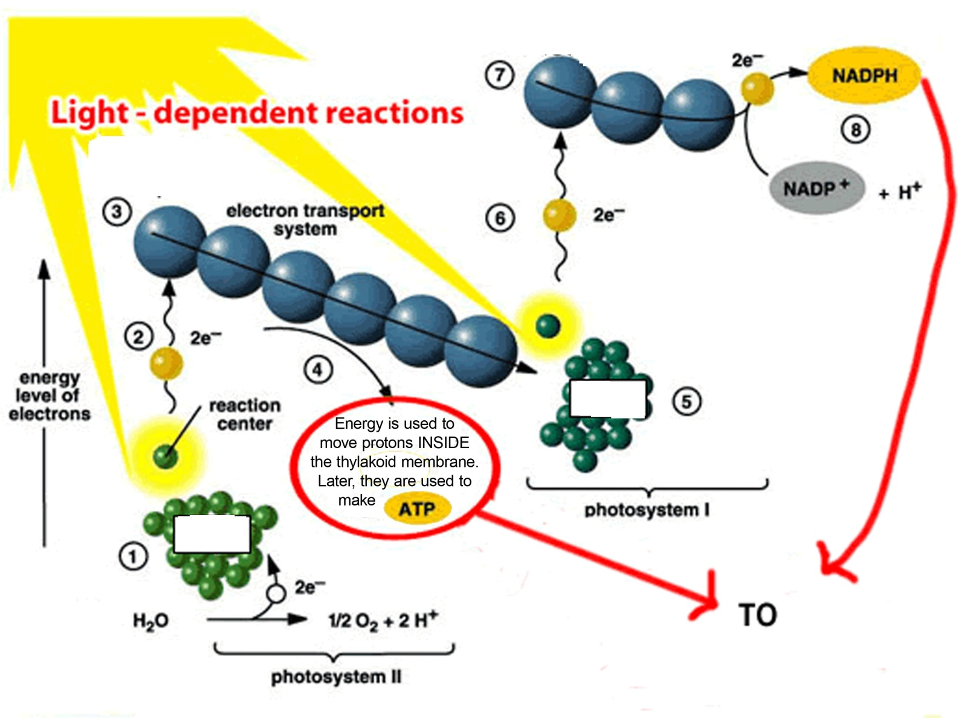
Light Reactions: How they happen:
1
2
3
4
5
6
7
8
Calvin Cycle (“Dark Reactions”) Basics (more later):
The Calvin Cycle builds __________ from _______. This is called ______________________
The energy for the process comes from _____ and __________ made during the ______________________.
This process also happens in the chloroplast (specifically, the __________).
Important Calvin Cycle Details
3 Main Phases: ______________, ________________, and ______________________________
What is RuBP, and why does it matter? ________________________________________________________
The enzyme RuBisCo: What does it do, and why does it matter? ___________________________________
________________________________________________________________________________________
What is the actual product of the Calvin Cycle? Hint, it’s NOT glucose. _________________________ Energy inputs
required per glucose made: ________________________________________________
The Calvin Cycle (Light-Independent Reactions)
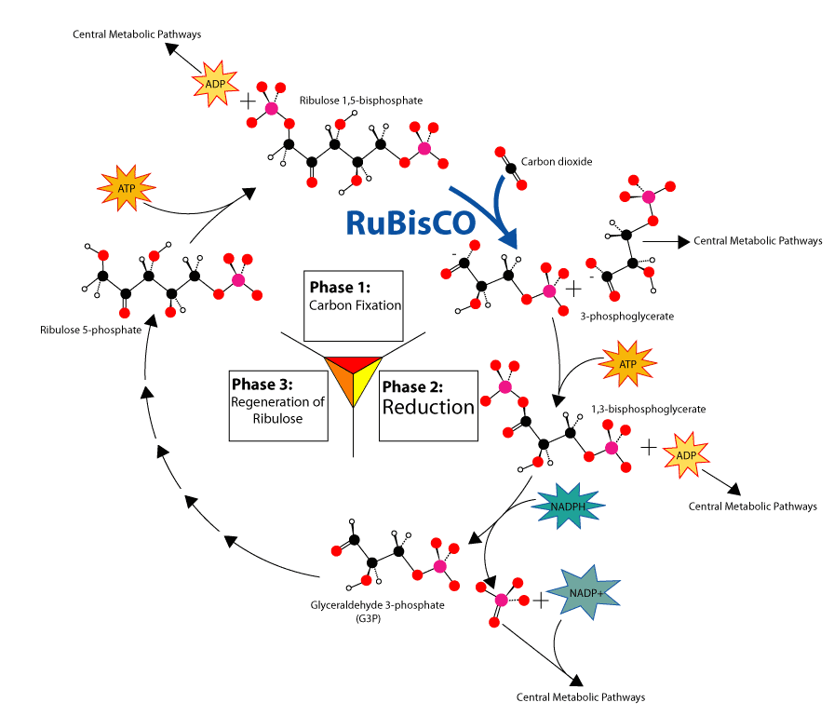

SUPER IMPORTANT PHOTOSYNTHESIS DIAGRAM

