Glycolysis

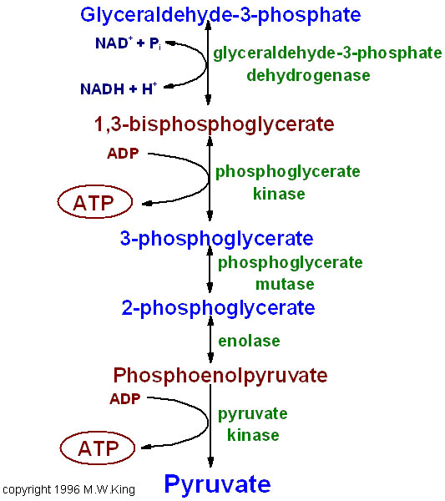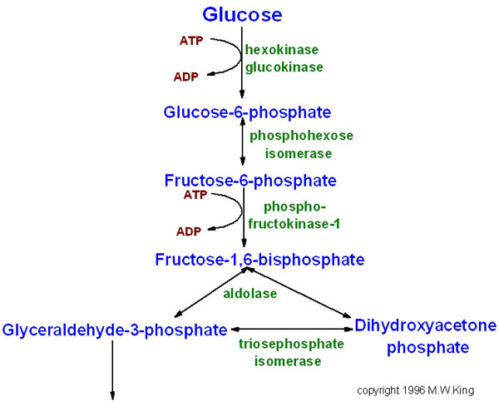

Glycolysis Notes:

SUMMARY EQUATION:

COMPLETE EQUATION:

Investment phase:

Payoff phase:

SUBSTRATE-LEVEL PHOSPHORYLATION:

NAD+ / NADH: Which has more energy?

What happens to Pyruvate next?

Anaerobic:

Aerobic: