Introduction to Cellular Respiration

Cellular Respiration: a complex _________________________________ that breaks down ___________________ in

order to _____________________.

How ATP Works

ATP = A __________ T_____ P________________ ADP = A_____________ D___ P_________________

Illustrate the process of ATP being used to release energy:

Releases Energy

Requires Energy

Areobic Respiration is respiration that requires _________________ anaerobic respiration does not.

Cellular Respiration of all kinds is a type of reaction where food molecules are _________________________.

Redox Reactions:

LEO the lion says GER:

The L_____ of E__________ is O_____________, the G________ of E_____________ is R________________

REDOX and Carbon

Adding oxygen to carbon is the _________________ of carbon, and releases energy.

Adding hydrogen to carbon is the ___________________ of carbon, and requires energy.

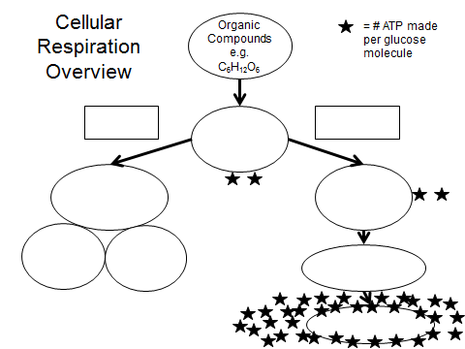

2.5 Billion years ago…. What happened?

Why is aerobic respiration so important? What did it allow to happen?

