What are stem cells?
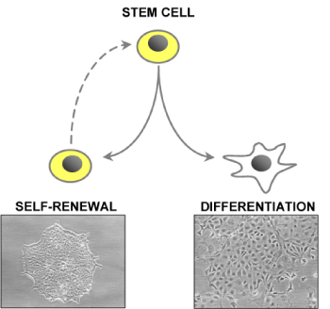
This article comes from the Institute for Stem Cell Research, UK.

Stem cells play a central role in the normal growth and development of animals and humans. Normal growth and development, including the maintenance of tissues and organs in the body, require the production of new cells via cell division. However, specialised cells, such as blood and muscle cells, are unable to divide and produce copies of themselves. Instead they are replenished from populations of stem cells, which have the unique ability to divide to produce both copies of themselves and other cell types. Stem cells, therefore, play a crucial role in supporting tissues such as blood, skin and gut, that undergo continuous turnover (cell replacement), and muscle, which can be built up according to the body's needs and often damaged during physical exertion.

Why are stem cells interesting?
Stem cells have three properties that distinguish them from other types of cells in the body and make them interesting to scientists.
1. Stem cells are unspecialised
Unlike a red blood cell, which carries oxygen through the blood stream, or a muscle cell that works with other cells to produce movement, a stem cell does not have any specialised physiological properties.
2. Stem cells are able to divide and produce copies of themselves
Stem cells can divide and produce identical copies of themselves, over and over again. This process is called self-renewal and continues throughout the life of the organism. In contrast, specialised cells such as blood and muscle do not normally replicate themselves, which means that when they are seriously damaged by disease or injury, they cannot replace themselves.
3. Stem cells have the potential to produce other cell types in the body
In addition to self-renewal, stem cells can also divide and produce cells that have the potential to become other more specialised cell types, such as blood and muscle cells. This process is called differentiation. Stem cells from different tissues, and from different stages of development, vary in the number and types of cells that they can give rise to. According to the classical view, as an organism develops the potential of a stem cell to produce any cell type in the body is gradually restricted.
Why are scientists so excited about stem cells?
Scientists are excited about the potential uses of stem cells in many different areas of research.
Stem cells provide an ideal model for studying the development of an organism
Stem cells may help us understand how a complex organism develops from a fertilised egg. In the laboratory, scientists can follow stem cells as they divide and become increasingly specialised, making skin, bone, brain, etc. Identifying the factors that determine whether a stem cell chooses to carry on replicating itself or differentiate into a specialised cell type, and into which cell type, will help scientists understand what controls normal embryonic development.
Stem cells have the ability to replace damaged cells in the body that would otherwise not be replenished
This property has led scientists to investigate the possible use of stem cells in regenerative medicine. Under certain conditions, stem cells can be induced to become other types of cell, such as blood cells and muscle cells, nerve cells, heart cells, or insulin-producing cells. Stem cells may, therefore, hold the key to replacing cells lost in many devastating diseases for which there are currently no cures, for example Parkinson's, heart disease, and diabetes. This potential benefit is responsible for the huge amount of interest in stem cell research.
Stem cells can be used to study disease processes, if directed to produce the specific cells that are damaged in those diseases.
In many cases it is extremely dificult to obtain the cells that are damaged in a disease, in order to study them in detail. Instead, they could be made from stem cells, either carrying the disease gene or engineered to contain disease genes. Scientists could then use the cells to model the disease, and so better understand the processes that are causing damage.
Stem cells can be directed to produce specific cell types in the laboratory that can be used to test drugs on
The potential to produce large numbers of specific cell types from human embryonic stem cells also has huge implications for drug discovery. If scientists are able to grow huge amounts of cells that are all the same then pharmaceutical companies could use them to test drugs. The initial stages of testing the effect and toxicity of drugs on cells could easily be investigated and the amount of testing done in animals significantly reduced.

