Endoplasmic Reticulum & Ribosomes
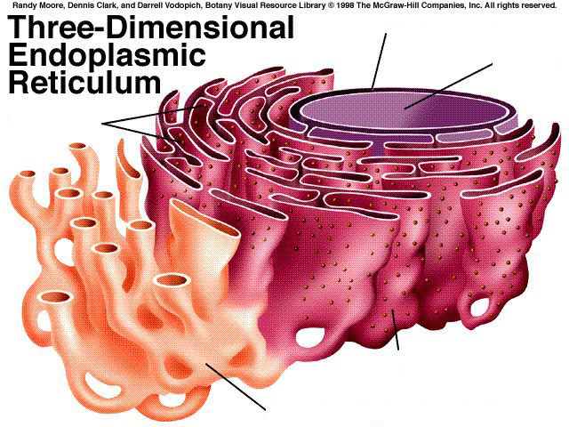

The endoplasmic reticulum made of folded ________________ __________________. The rough er has ____________________ attached to it, but the smooth ER has none. It is connected to the _______________________. Proteins are made by ____________________ in both prokaryotic and eukaryotic cells.

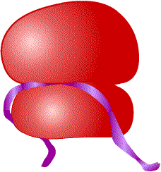 | Ribosome structure & Function: (SUPER IMPORTANT CELL PART)
Endoplasmic Reticulum | Structure & Function

