The Cell Membrane
Do Now: Macromolecule Review
Macromolecule | Proteins |  | Nucleic Acids
Monomers |  | monosaccharides |  | Lipids

Organelles are ____________________________ . They are like the ___________ of an organism
Systems
A system is a group of related ______ that work together to perform some function or behavior.
The car as a system
Most important parts least important parts
Structure | Function |  | Structure | Function
Engine | Burns fuel to provide energy |  | Cup holder | Holds tasty beverages

If one part of a system changes… __________________________________________________________
Cells as Systems: Cells are systems that do what? ____________________________________________
Cell Membrane
Where can you find cell membranes?
Structure: Label hydrophilic &
hydrophobic parts
Function:

THE CELL MEMBRANE

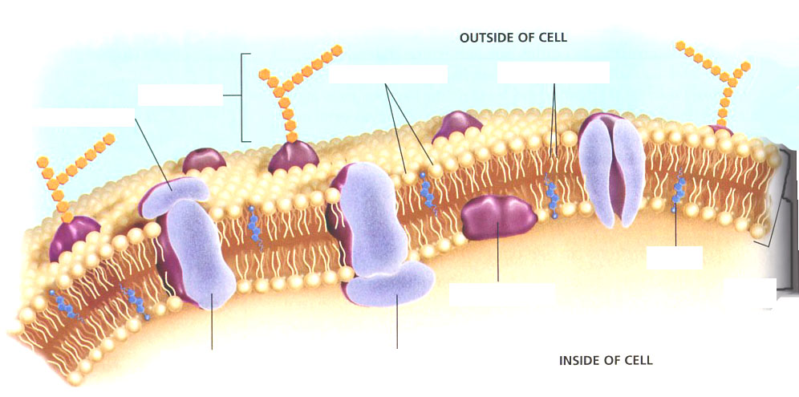

Phospholipid
Phospholipid bilayer
Membrane proteins
fluid mosaic model
selective permeability

HOMEWORK:

