Organic Chemistry
1. Construct each of the compounds below, and then have Mr. Tomasino check each.
2. Classify each compound as a(n) Alkane, Alkene, Alkyne, Alcohol, Aldehyde/ Ketone, Carboxylic Acid, Amine, or Amino Acid.
3. Circle the Functional Group/ Bonds:
Example:
Propanoic Acid 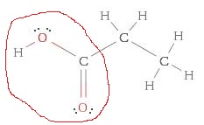Carboxylic Acid (Circled)
Name | Structure | Classification
Butane | 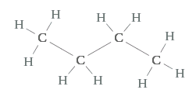
Ethene  (Ethylene) | 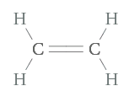
Ethanol | 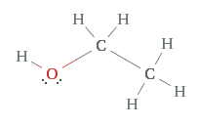
Formaldehyde  (I make labs smell terrible) | 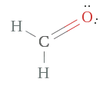
Acetone | 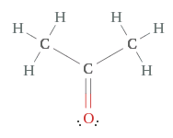
Acetic Acid | 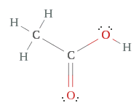
Methylamine | 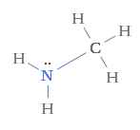
Glycine | 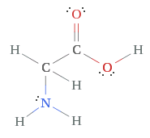
Alanine | 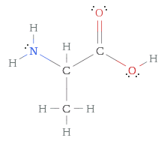
Glycerol | 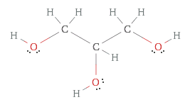
Cheat Sheet | -OH Alcohol  - NH₂ Amine  - 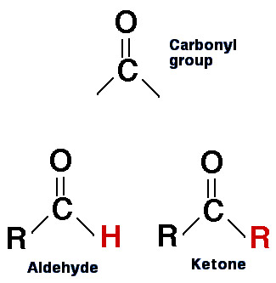  - Carboxylic Acid  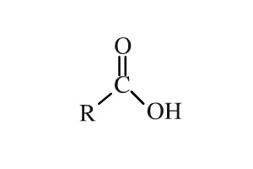 | - Black = Carbon  - White = Hydrogen  - Blue = Nitrogen  - Red = Oxygen

