Kingdom Exploration
Modified from: Prentice Hall Laboratory Manual

Today you will use one the fundamental tools to a biologist….the microscope. This tool is used in a variety of ways to help biologists understand the living world. You will use the microscope to observe the four kingdoms in the domain Eukarya.

Part I – Introduction to the Microscope

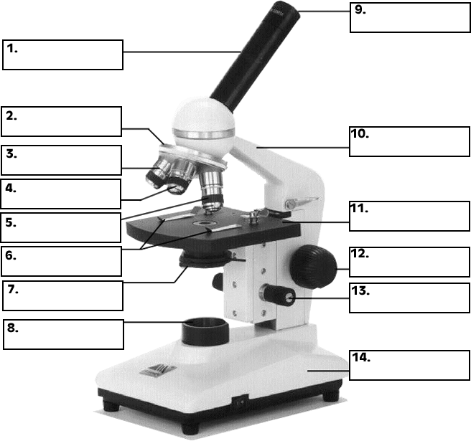

The eyepiece of a microscope usually has a magnification of 10X. To calculate the total magnification of each power of a microscope, multiply the magnification of the eyepiece by the magnification of the objective lens. For example, if the medium-power objective lens is 10X and the eyepiece is 10X, the total medium-power magnification of the microscope is 100X. In Table 1, record the magnifications available on your microscope.

Data Table 1: Total Magnification
Objective | Magnification of Objective | Magnification of Eyepiece | Total Magnification
Low Power
Medium Power
High Power
Other

When you look into the eyepiece of a microscope, the brightly lit circle you see is called the field of view. When you look through the high-power objective lens, the field of view has a much smaller diameter than the field of view when you look through the low-power objective lens.

To observe organisms with a microscope, follow the basic steps described below for each objective lens. Always start with the low-powered lens first!

Low Power Make sure that the low-power lens is in place. Focus only with the coarse focus knob (large knob), and use the diaphragm to adjust the incoming light so that you can see details. Move the slide slightly to make sure that what you see through the eyepiece is actually on the slide (not just the glass of the lens). When you locate what you want to look at, position it in the middle of the field of view. Then adjust the focus with the fine focus knob (small knob).

Medium Power Switch to medium power by swinging the middle-sized lens into place. Adjust the focus with the fine focus knob. CAUTION: Never use the coarse adjustment when focusing the high-power objective lenses. You could break the slide or damage the lens. Adjust the lighting. In general, you will need to let in more light as you increase magnification. Again, move the slide slightly until the object you are observing is in the middle of the field of view.

High Power Switch to high power by moving the longer lens into place. Adjust the focus only with the fine focus knob. If this doesn’t work, switch back to medium power and repeat the steps above. If you can’t see the object on medium power, switch to low power and start over.

Part II – Size of the Field of View

- Place a transparent metric ruler on the microscope stage so that the millimeter marks fall across the diameter of the circular opening where the light comes through.

- Look through the low-power lens. Focus on the millimeter marks. Move the ruler so that one mark lines up at one side of the field of view. Measure the diameter of the field of view. Record your measurement in your lab notebook.

- Calculate the diameter of the field of view for the medium-power objective lens using the formula below. Record the result of your calculation.
Diameter of medium-power field of view
(diameter of low-power field of view) X (power of low-power objective)

power of medium-power objective
=

- Calculate the diameter of the field of view for the high-power objective lens using the formula below. Record the result of your calculation.
Diameter of high-power field of view
(diameter of low-power field of view) X (power of low-power objective)

power of high-power objective
=

Calculations:

Data Table II: FOV Size

Objective Lens | Total* Magnification | Measured FOV size | Calculated FOV size
Low (4x) |  | mm | N/A
Medium (10x) |  | N/A
High (40x) |  | N/A

Part III - Answer the following questions.

- When do you use the coarse focus knob on a microscope?

__________________________________________________________________________________________

- Suppose you are looking at protists under the microscope and cannot see anything on low power. What adjustment could you make to the microscope that might help you see the protists, without switching to a higher magnification?

__________________________________________________________________________________________

__________________________________________________________________________________________

- Suppose you focused on an organism using medium power, but then cannot see the organism after switching to high power. What should you do?

__________________________________________________________________________________________

__________________________________________________________________________________________

Parts IV, V, VI, & VII: in each of these sections you will be record observations of specimens from each traditional kingdom of domain Eukyra: plants, animals, protists, and fungi.

1. Observe and sketch each prepared slide, using good microscope technique.

2. Complete the data table for each specimen including its name, the magnification used to make the sketch, and an estimation of the size of the cells you see.

3. When finished, return the microscope to low power. At the end of the class, make sure the lamp is off.
PART IV: PLANT SPECIMENS, KINGDOM PLANTAE
Specimen: | Specimen:
Magnification: | Magnification:
Estimated cell size: | Estimated Cell Size:

PART V: ANIMAL SPECIMENS, KINGDOM ANIMALIA

Specimen: | Specimen:
Magnification: | Magnification:
Estimated cell size: | Estimated Cell Size:

PART VI: PROTIST SPECIMENS, KINGDOM* PROTISTA

Specimen: | Specimen:
Magnification: | Magnification:
Estimated cell size: | Estimated Cell Size:

PART VII: FUNGUS SPECIMENS, KINGDOM FUNGI

Specimen: | Specimen:
Magnification: | Magnification:
Estimated cell size: | Estimated Cell Size:

Part VIII: ANALYSIS & CONCLUSIONS: Answer the following questions related to the microscope lab with complete sentences on a separate sheet of paper. Include your answers with the lab report you submit.

ANALYSIS:

1. What does the “compound” in compound light microscope mean?
2. How can you determine the total magnification of a microscope?
3. Why is it so important to always begin viewing a slide with the low power objective?
4. What is the function of the microscope’s diaphragm?

CONLUSIONS: Answer the following questions related to the microscope lab. Include your answers with the lab report you submit.

1. Which levels of biological organization are the correct sizes to be investigated with a compound light microscope?
2. What are the three domains of life? Which domain are you a member of? Which domain do plants belong to?
3. What is taxonomy, and what purpose does it serve in biology?

