VI. CIRCULATORY SYSTEM
1. purpose of system:
2. annelids:
3. arthropods / open circulatory system:
A. Vertebrate Circulatory Systems
1. arteries
a. structure:
b. direction:
c. pressure:
2. capillaries
a. structure:
b. function:
3. veins
a. direction:
b. pressure:
c. unidirectional valves:
B. Patterns of Circulation in Vertebrates
1. fish (+ problem):
2. other higher animals
a. pulmonary circuit:
b. systemic circuit:
C. The Heart
1. 2 chamber hearts
a. what organisms?
b. inefficiency:
2. 4 chamber hearts
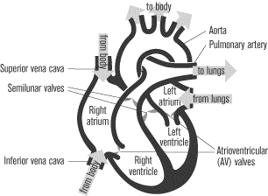
a. what organisms?
b. atria:
c. ventricles:
3. blood flow
a. receives blood from body:
i. veins bringing blood:
b. pumps blood to lungs:
c. receives blood from lungs:
d. pumps blood to body:
i. aorta:
4. control of beating
a. cardiac muscle:
b. sinoatrial nerve:
c. atrioventricular nerve:
D. The Blood
1. Plasma:
2. Red blood cells:
a. hemoglobin
3. white blood cells:
4. platelet:
a. thromboplastin:
b. fibrinogen / fibrin:
E. Blood Types
1. antigens:
2. antibodies:

