MISSION 6.2: Characters & aN Outline
I. Mission
A. Complete the character outlines for your protagonist and antagonist.
B. Complete the Freytag plot outline describing the 5 acts of your story. Use the diagram below to help think about what belongs where in your story.
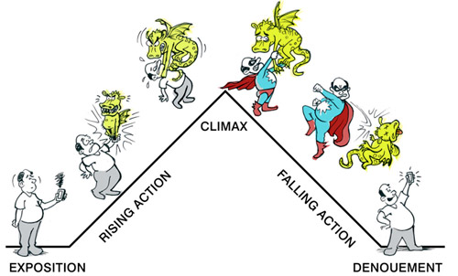
C. Wrap it up.
1. Make sure your 5-digit team number and full name appears on your character development sheet AND the plot outline. Put them in your physical team folder.
2. Make a note in your team’s communication file that you have completed mission 2. I will check before our next class.
MISSION 6.3: Typing.com Account
I. Mission
A. Use Chrome to navigate to www.typing.com
B. Click “student login” at top and follow the instructions to create an account. DO NOT USE A PASSWORD YOU USE FOR OTHER ACCOUNTS. THE PASSWORD YOU CREATE WILL NOT BE SECURE.
C. Record your typing.com username and password in your team member list file. Normally, YOU SHOULD NOT SHARE USERNAME OR PASSWORD INFORMATION. However, with an unimportant account like this one that has little personal information, don’t worry. This is just so I can check in on your progress in the future.
D. After finishing steps A-C above, make a note in your team’s communication file that you have completed mission 3.

