PCR: Polymerase Chain Reaction
Discovered 1983, published 1986, Nobel Prize 1993
Importance: Makes MANY copies of a target DNA sequence, required for many biotech applications, such as DNA fingerprinting, gene splicing, and others.
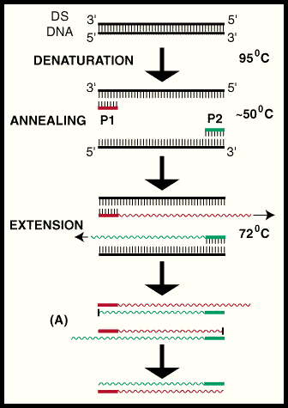
DNA amplification by the polymerase chain reaction (PCR) is schematically outlined in the diagram below. There are 3 general steps to the process that are repeated for a number of cycles to exponentially increase the number of copies of a specific target region. Genomic DNA is normally double-stranded (DS-DNA).
STEP 1 is to first unzip the DS-DNA, also called denaturation, into two complementary single strands of DNA by heating the reaction mix to 95 degrees Celsius.
STEP 2 isolates the target region of the Genomic DNA by landing 2 primers (P1 & P2) which exactly match two 20-30 unique base pair regions that bookend the target region. This is called annealing. Once time is allowed for the primers to land on the sites,
STEP 3 involves heating the mix to 72 degrees at which point a special polymerase builds the DNA strand starting at the primers and continuing in the 5 prime direction. This is called extension.
These three steps are repeated 25-40 times to produce millions of exact copies of the target region of DNA. Because during the second cycle of this process, extension can occur on both the original copy of genomic DNA and the newest pieces (the colored ones in the diagram) subsequent extensions are quickly limited precisely to the target region (A).

Name: _____________________________________ Date: __________________ Period: _____
1. What is the function of each of the following in a PCR reaction?
- Heat:
- Primer:
- Taq polymerase:
2. Briefly describe what the thermocycler (PCR machine) does and what happens in each of the following three steps of Polymerase Chain Reaction:
- Denaturing:
- Annealing:
- Extension:
3. Suppose you start with one double-stranded molecule of DNA and you want to amplify this one DNA molecule by PCR. You add an excess of a two single-stranded primers, each of which will anneal to the DNA molecule in only one place, copying the segment of DNA between them. Draw representations of the DNA and primers in each of 3 cycles. Label the template DNA, the primers, and the newly synthesized DNA strands. Show the direction of DNA synthesis on each strand.
4. How many molecules of double-stranded target-only DNA will you have after three cycles? After six cycles? After 100 cycles? (you may leave your answer in exponential form)

5. Consider the following piece of a DNA molecule:

5’…GGG-AAA-TTT-AAA-CCC-…[MANY BASES]…AAA-CAT-TAG-CAT-TAG…3’

What 2 primer molecules would you use to amplify the DNA segment? Each primer should be 15 nucleotides in length. Label the 3’ and 5’ ends of each molecule.

