Name: _______________________________________________ Date: _______________ Period: ______

Hunting for ORFs

An open reading frame, or ORF, is a segment of DNA that may code for a protein. In this assignment, you will analyze a 54 nucleotide sequence of DNA in order to find the largest possible ORF. Computer algorithms that perform this analysis are used to analyze DNA sequences and determine proteins they might produce.

The following sequence of DNA can be read in six reading frames. Three in the forward and three in the reverse direction.
5' 3'
atgcccaagc tgaatagcgt agaggggttt tcatcatttg aggacgatgt ataa

First, figure out the other 3’ 5’ DNA strand: Write a dash (-) after every 10 bases.

- _______________________________________________________________________________

Next: Figure out the 6 possible DNA reading frames, 3 from each DNA strand. Be sure to label the 5’ and 3’ ends. Write a dash (-) between codons.

- __________________________________________________________________________________

- ___________________________________________________________________________________

- ___________________________________________________________________________________

- ___________________________________________________________________________________

- ___________________________________________________________________________________

- ___________________________________________________________________________________

Next: Figure out the 6 possible mRNA molecules that could be produced. Remember that transcription builds a new RNA in the 5’3’ direction. WRITE ALL mRNA SEQUENCES IN THE 5’ TO 3’ DIRECTION, since this is how they will be translated at the ribosome. Write a dash (-) between codons.

- __________________________________________________________________________________

- ___________________________________________________________________________________

- ___________________________________________________________________________________

- ___________________________________________________________________________________

- ___________________________________________________________________________________

- ___________________________________________________________________________________

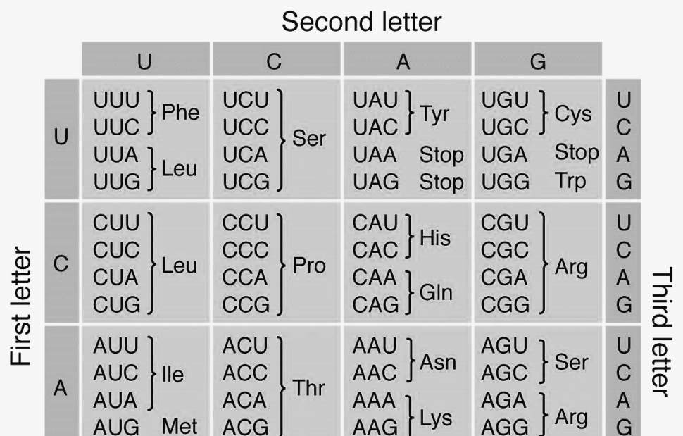

Next: Translate the RNA sequences into amino acid sequences using the universal genetic code. Use a * if a stop codon is indicated. Write a dash (-) between amino acids.

- __________________________________________________________________________________

- ___________________________________________________________________________________

- ___________________________________________________________________________________

- ___________________________________________________________________________________

- ___________________________________________________________________________________

- ___________________________________________________________________________________

Finally: Find the largest open reading frame (ORF) that could be the beginning of a protein. This will be the longest sequence that begins with AUG / methionine and is not interrupted by a stop codon. Circle it on the original DNA sequence.

