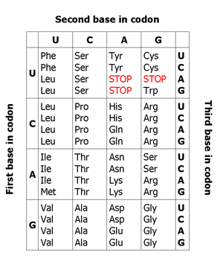
Transcription and Translation Practice

Directions: Use the DNA sequences to figure out what the amino acid sequence of the protein they code for is.

STEP 1: transcribe a pre-mRNA sequence
STEP 2: remove introns from the sequence
STEP 3: translate into amino acids by using the universal genetic code. Begin with the first AUG codon from the 5’ end. (mRNA read from left to right is in the 5’ 3’ direction) End at the first stop codon.

1: DNA template strand:

Exon 1 |  |  |  |  |  |  |  |  |  |  |  |  |  | Intron 1 |  |  |  |  | Exon 2 |  |  |  |  |  | Intron 2 |  |  |  | Exon 3
T | C | C | T | A | T | A | C | T | G | C | C | A | G | G | A | T | A | C | A | T | A | C | G | G | G | C | T | A | A | A | A | A | T | T | G | G | C | A

Pre-mRNA:

Mature mRNA:

Amino acid sequence:

2: DNA coding strand from prokaryote:

ATC-GGG-ATG-CTC-CCC-TAA-GCC-AAA-AGT-TAG-ATC

Pre-mRNA:

__________________________________________________________________________________________________

Mature mRNA:

__________________________________________________________________________________________________

Amino acid sequence:

