Transcription: DNA RNA

DNA strands are antiparallel

DNA strands in a double helix are oriented in opposite directions.

The numbers 5’ and 3’ refer to

________________________________________________

________________________________________________

The 5’ end has a ________________, the 3’ end has a

___________________.

Label the 4 ends of the DNA strands shown as 5’ or 3’

Polymerases: Enzymes that __________________________________________________________________________

What direction do DNA and RNA polymerase work? ______________________________________________

DNA Replication Enzymes

Enzyme | Function
Helicase
 | Makes a new DNA strand complimentary to a template strand by joining nucleotides together.
DNA Ligase

Transcription: The process of _________________________________________________________________________
Nucleic Acid Functions
DNA | RNA
Central Dogma: Add the names of the molecules in the circles, and the processes with the arrows:

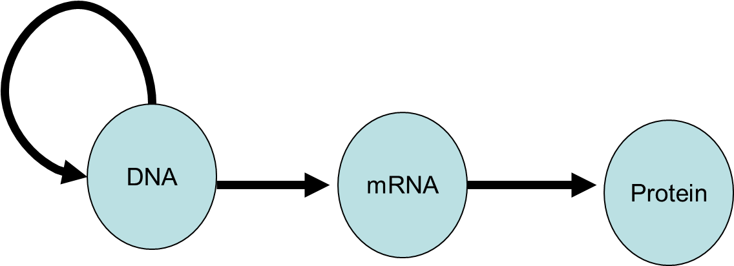

DNA vs. RNA Structure
 | DNA | RNA
# of strands
Sugar used
Bases used

Why can RNA molecules have so many different structures and functions? _____________________________________

__________________________________________________________________________________________________

Types of RNA
mRNA (messenger RNA) is a single stranded nucleic acid molecule that

___________________________________________________________________________________________

There, it is used by ribosomes as ___________________ for building a _________________ molecule.

tRNA and rRNA are used to build proteins during the process of _________________________.

Polymerases: enzymes that make _________________________________

DNA strands are often referred to as the template strand and the coding strand.

The template strand is _______________________________________________________________________

The coding strand __________________________________________________________________________

Promoter: A sequence of DNA preceding the gene to be transcribed where _______________________ and other proteins attach _____________ transcription begins.

The direction of transcription: The template strand is read in the _____________ direction, therefore the new mRNA strand is built in the _______________ direction.

PRACTICE: What is the sequence of bases in an mRNA molecule produced by transcription of the DNA molecule shown?

DNA:
Coding Strand: 5’ ATG – CTC – GAG – TTA – TAT 3’
Template Strand: 3’ TAC – GAG – CTC – AAT – ATA 5’

mRNA molecule: 5’ ____ - ____ - ____ - ____ - ____ 3’

Reverse transcriptase is an enzyme found in retroviruses, like HIV. What do you think it does? ___________________

__________________________________________________________________________________________________

