Molecular Genetics Introduction

KEY TERMS & CONCEPTS:

- DNA is a chemical ____________ made of _________________.
- The ______________________________ in a DNA molecule are instructions for making _____________.
- A gene is a piece of ______ instructions for making 1 _____________.
_____________________________________________________________________________________

In a code, a ____ is 1 single piece of information. In language, these are ___________. In DNA, these are ______________.

Program: “a planned, coordinated group of activities, procedures, etc., often for a specific purpose.“

DNA is a ______________ code for ________.

How many DNA bases are there? _______ What are they (use letter abbreviations) ___, ___, ___, ___

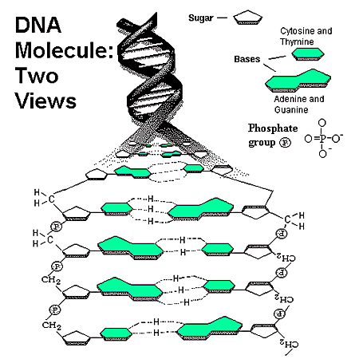

COMPLIMENTARY BASE PAIRING

- The 2 strands of a DNA molecule are held together by __________________________ between nucleotides
- Because they have different shapes, ___ and ____ stick together, as do ____ and ____.
- ____ is always across from ____ and ____ is always across from ____ in a DNA molecule.

Practice:

One strand sequence is A T C G G C T A T A
Opposite strand is ___, ___, ___, ___, ___, ___, ___, ___, ___, ____

4 Big reasons to study DNA

- _________________________

- _________________________

- _________________________

- _________________________

