Non-Mendelian Inheritance

Mendelian Inheritance: 1 gene, one trait, one dominant allele

Non-mendelian inheritance we have already seen:

_______________________, _________________________, ______________________

Polygenic Traits: __________________________________________________________________________

Examples: ________________________________________

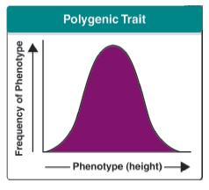

Polygenic Trait Example: HLA complex

Function: Used by immune system to _______________________________________________

Number of genotypes possible: _________________________

Evolutionary advantage: _________________________________________________________

Pleiotropy: ________________________________________________________________________________

Examples: ___________________________________________

Sex-Influenced Traits: _______________________________________________________________________

Examples: _________________________________________________

Heritability: Heritability is a measurement of what fraction of _________________________________ is a

result of __________________________________ in a population.

NATURE vs. NURTURE: What does the research say about the heritability of psychological or personality traits?

Homosexuality twin study (Bailey et. al)

For a given homosexual female, ______ of identical twins are also homosexual, as compared to _____ of adopted sisters.

Schizophrenia: estimated genetic contribution: _________

Other genetically-influenced traits: _____________________________________________________

How heritable are personality traits, like “extraversion” and “conscientiousness?” _______________

