Aerobic Respiration: Electron Transport Chain + Chemiosmosis

4 Steps of Aerobic Respiration:

1. Glycolysis: ___________ _____________ + ___________ + ______________

2. Krebs: _____________ __________ + ___________ + __________ + _____________

3. Electron Transport chain: electrons from ___________ and _________ are used to create a _________________ across the inner membrane of the mitochondria

4. Chemiosmosis: The flow of _____________ across the ________________________ of the mitochondria powers the ______________________ enzyme, which produces ________ additional ATP molecules from ADP + Pi.

In The Mitochondria

The ___________________________________ is where H+ ions are pumped by the _____.

The _____________, where the ___________________ occurs has a __________ H+ concentration than the ________.

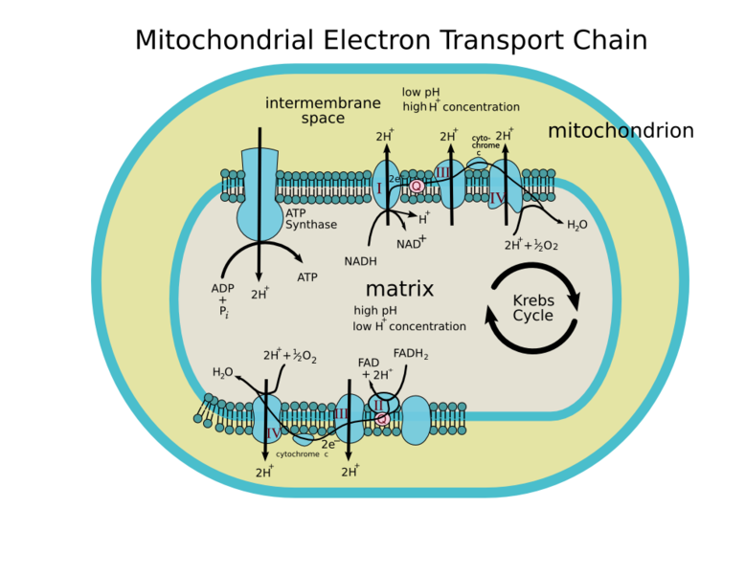
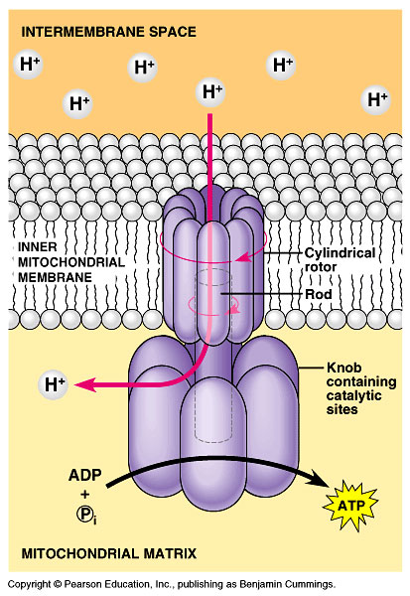

RECAP: ETC

* The _______________ ripped from food molecules (like glucose) during glycolysis and the Krebs Cycle are carried to

the electron transport chain by __________ and __________.

* The ETC is a series of ______________ embedded in the mitochondrial _______________________.

* The ___________________________ through the ETC powers the pumping of _____ ions from the mitochondrial

________ into the ___________________________________. At the end of the ETC, the electrons are

transferred to __________, forming ____________ (with H+).

RECAP: Chemiosmosis & ATP Synthase

- The flow of ______________ (H+) down their concentration gradient through the enzyme ________________ (aka chemiosmosis) powers the synthesis of ATP from ADP + Pi (located in the matrix).

- The ETC + chemiosmosis produces _____________ from the energy that was in _________________________.

The Overall Aerobic Respiration Equation

