Fermentation Notes

LACTIC ACID FERMENTATION:

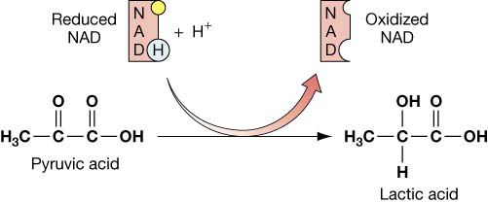

Alcoholic Fermentation + Glycolysis:

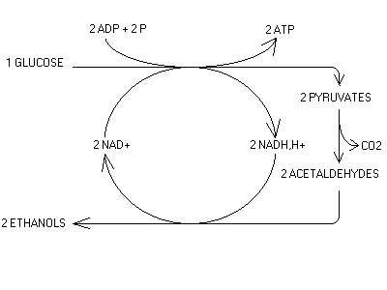
Mark the diagram shown to distinguish fermentation and glycolysis in the pathway shown.

LEO says GER. Explain:

In fermentation, _________ is oxidized to ______, and the waste products are reduced.

Fermentation is wasteful: Explain:

THE BIG IDEAS:

THE FUNCTION OF FERMENTATION IS TO _____________________________________________________.

Alcoholic fermentation (like done by ___________) produces ________ and ___________. Lactic acid

fermentation (like done by human __________ cells) produces lactic acid. There are many other types as well.

Fermentation is inefficient: the waste products of glycolysis are ________________ by NADH, which adds chemical energy to them.

