Golgi Apparatus & Lysosomes

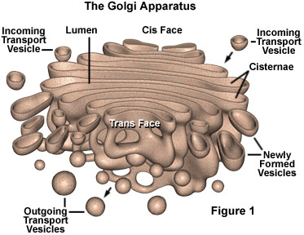 | Golgi apparatus:  Structure:  Function:
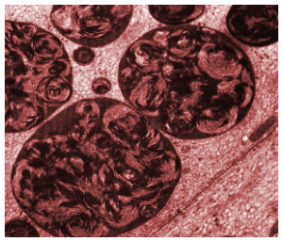 | Lysosome:  Structure:  Function:

