Nucleus
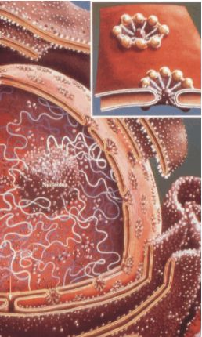
Structure:

Function:

nucleus
nuclear envelope
nuclear pores
chromatin
nucleolus

