The Nervous System

The nervous system functions by the almost instantaneous transmission of electrochemical signals. The means of transmission are highly specialized cells known as neurons, which are the functional unit of the nervous system.
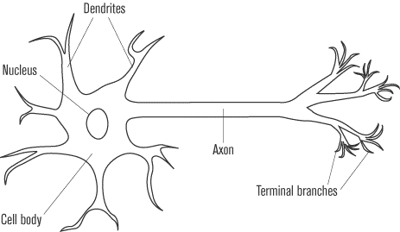
The neuron is an elongated cell that usually consists of three main parts: the dendrites, the cell body, and the axon. The typical neuron contains many dendrites, which have the appearance of thin branches extending from the cell body. The cell body of the neuron contains the nucleus and organelles of the cell. The axon, which can sometimes be thousands of times longer than the rest of the neuron, is a single, long projection extending from the cell body. The axon usually ends in several small branches known as the axon terminals. Neurons are often connected in chains and networks, yet they never actually come in contact with one another. The axon terminals of one neuron is separated from the dendrites of an adjacent neuron by a small gap known as a synapse.
The electrical impulse moving through a neuron begins in the dendrites. From there, it passes through the cell body and then travels along the axon. The impulse always follows the same path from dendrite to cell body to axon. When the electrical impulse reaches the synapse at the end of the axon, it causes the release of specialized chemicals known as neurotransmitters. These neurotransmitters carry the signal across the synapse to the dendrites of the next neuron, starting the process again in the next cell.

The Resting Potential
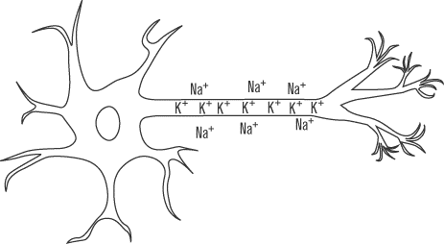
To understand the nature of the electrical impulse that travels along the neuron, it is necessary to look at the changes that occur in a neuron between when it is at rest and when it is carrying an impulse. When there is no impulse traveling through a neuron, the cell is at its resting potential and the inside of the cell contains a negative charge in relation to the outside.
Maintaining a negative charge inside the cell is an active process that requires energy. The cell membrane of the neuron contains a protein called Na⁺/K⁺ ATPase that uses the energy provided by one molecule of ATP to pump three positively charged sodium atoms (Na⁺) out of the cell, while simultaneously taking into the cell two positively charged potassium ions (K⁺). The sodium-potassium pump builds up a high concentration of sodium ions outside the cell and an excess of potassium ions inside the cell. These ions naturally want to diffuse across the membrane to regularize the distribution. However, one of the special properties of phospholipid cell membranes is that they bar passage to ions unless there is a special protein channel that allows a particular ion in or out. No such channel exists for the sodium that is built up outside the cell, though there are potassium leak channels that allow some of the potassium ions to flow out of the cell. The difference in ion concentrations creates a net potential difference across the cell membrane of approximately –70 mV (millivolts), which is the value of the resting potential.

The Action Potential

While most cells have some sort of resting potential from the movement of ions across their membranes, neurons are among only a few types of cells that can also form an action potential. The action potential is the electrochemical impulse that can travel along the neuron. In addition to the Na⁺/K⁺ ATPase and potassium leak channel proteins, the neuron membrane contains voltage-gated proteins. These proteins respond to changes in the membrane potential by opening to allow certain ions to cross that would not normally be able to do so. The neuron contains both voltage-gated sodium channels and voltage-gated potassium channels, which open under different circumstances.
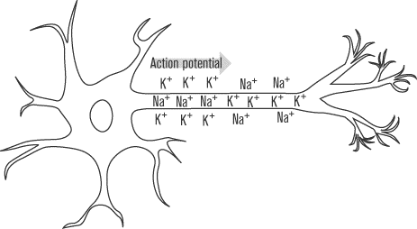
The action potential begins when chemical signals from another neuron manage to depolarize, or make less negative, the potential of the cell membrane in one localized area of the neuron cell membrane, usually in the dendrites. If the neuron is stimulated enough so that the cell membrane potential in that area manages to reach as high as –50 mV (from the resting potential of –70 mV), the voltage-gated sodium channels in that region of the membrane open up. The voltage at which the voltage-gated channels open is called the threshold potential, so the threshold potential in this case is –50 mV. Since there is a large concentration of positive sodium ions just outside the cell membrane that have been pumped out by Na⁺/K⁺ ATPase, when the voltage-gated channels open, these sodium ions follow the concentration gradient and rush into the cell. With the flood of positive ions, the cell continues to depolarize. Eventually the membrane potential gets as high as +35 mV, at which point the voltage-gated sodium channels close again and voltage-gated potassium channels reach their threshold and open up. The positive potassium ions concentrated in the cell now rush out of the neuron, repolarizing the cell membrane to its negative resting potential. The membrane potential continues to drop, even beyond –70 mV, until the voltage-gated potassium channels close once again at around –90 mV. With the voltage-gated proteins closed, the Na⁺/K⁺ ATPase and the potassium leak channels work to restore the membrane potential to its original polarized state of –70 mV. The whole process takes approximately one millisecond to occur.
The action potential does not occur in one localized area of the neuron and then stop: it travels down the length of the neuron. When one portion of the neuron’s cell membrane undergoes an action potential, the entering sodium atoms not only diffuse into and out of the neuron, they also diffuse along the neuron’s length. These sodium ions depolarize the surrounding areas of the neuron’s cell membrane to the threshold potential, at which point the voltage-gated sodium channels in those regions open, creating an action potential. This cycle continues to occur along the entire length of the neuron in a chain reaction.
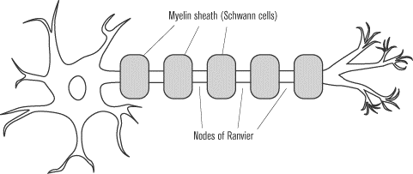
During the time it takes the neuron to repolarize back from +35 mV to –70 mV, the voltage-gated sodium channels will not reopen. This lag prevents the action potential from moving backward to regions of the cell membrane that have already experienced an action potential.

Speeding Up the Action Potential

Axons of many neurons are surrounded by a structure known as the myelin sheath, a structure that helps to speed up the movement of action potentials along the axon. The sheath is built of Schwann cells, which wrap themselves around the axon of the neuron, leaving small gaps in between known as the nodes of Ranvier.

The sodium and potassium ions that cause the action potential are only able to cross the cell membrane at the nodes of Ranvier, so the action potential does not have to occur along the entire length of the axon. Instead, when the action potential is triggered at one node, the sodium ions that enter the neuron will trigger an action potential at the next node. This causes the action potential to jump from node to node, greatly increasing its speed. This jumping of the action potential is called saltatory conduction. Some diseases such as multiple sclerosis can damage the myelin sheaths, greatly impeding conduction of impulses along the neurons.

Strength of the Signal

There is no such thing as a stronger or weaker action potential. If a neuron reaches the threshold to trigger an action potential, then the entire sequence of events, from depolarization to repolarization, will occur, and the same threshold potentials will be reached. But it’s obvious that every signal can’t trigger an identical response, or else neurons would never be able to convey any useful information. For example, if the feel of lukewarm water and the burn of a hot iron triggered the same response, our sense of touch would be rather useless.
The body communicates a stronger message not by creating a larger action potential, but by firing action potentials more rapidly. The burn of an iron may cause the heat receptors in our skin to fire action potentials at a rate of up to one hundred action potentials per second, while lukewarm water might trigger action potentials at less than half that rate.

Transmitting an Impulse Between Neurons

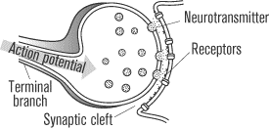
Neurons cannot directly pass an action potential from one to the next because of the synapses between them. Instead, neurons communicate across the synaptic clefts by the means of chemical signals known as neurotransmitters. When an action potential reaches the synapse, it causes the release of vesicles of these neurotransmitters, which diffuse across the gap and bind to receptors in the dendrites of the adjacent neuron. The neurotransmitters can be excitatory, causing an action potential in the next neuron, or inhibitory, preventing one. Excitatory neurotransmitters cause the target neuron to allow positive ions to enter it, which may or may not be enough to cause the membrane to reach the threshold potential of –50 mV that is needed to open the -voltage-gated sodium channels and initiate an action potential. Inhibitory neurotransmitters cause the target neuron to allow entrance to negative ions, carrying the neuron further from threshold and preventing it from firing an action potential.
To form the nervous system, neurons are organized in a dense network. Each neuron shares a synapse with many other neurons, exposing each neuron to excitatory and inhibitory neurotransmitters simultaneously. The effects of all of the neurotransmitters working on a neuron at a given time are added up to determine whether or not an action potential will be fired. After a neurotransmitter has its effect on the target neuron, it usually either diffuses away from the synapse, is deactivated by enzymes in the synapse, or is absorbed by surrounding cells.

Nervous System Organization

As animals became more complex, their nervous systems evolved from the simple, unorganized networks of nerves that are found in cnidarians, such as jellyfish, and became more complicated and coordinated by a central control. Annelids and mollusks have simple, organized clusters of neurons known as ganglia. Many ganglia fuse in the head region of these organisms to form a primitive brain. Arthropods exhibit a more complex nervous system that includes many sensory organs such as antennae and compound eyes. Vertebrates mark the culmination of nervous system evolution. The vertebrate system is highly centralized, with a large brain that can process complex information and numerous specialized sensory organs.

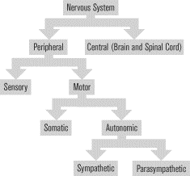
The Vertebrate Nervous System

The vertebrate nervous system contains billions of individual neurons but can be divided into two main parts: the central nervous system (CNS) and the peripheral nervous system (PNS). The central nervous system, as its name implies, acts as central command. It receives sensory input from all regions of the body, integrates this information, and creates a response. The central nervous system controls the most basic functions essential for survival, such as breathing and digestion, and it is responsible for complex behavior and, in humans, consciousness. The peripheral nervous system refers to the pathways through which the central nervous system communicates with the rest of the organism.
In highly evolved systems, such as the human nervous system, there are actually three types of neural building blocks: sensory, motor, and interneurons.
Sensory neurons: After an organism’s sense organs receive a stimulus from the environment, sensory neurons send that information back to the central nervous system. Also called afferent neurons.
Motor neurons: In response to some stimulus or as a voluntary action, motor neurons carry information away from the central nervous system to an organ or muscle. Also called efferent neurons.
Interneurons: Provide the connection between sensory neurons and motor neurons.

The Central Nervous System

The central nervous system consists of the brain and the spinal cord. The spinal cord is a long cylinder of nervous tissue that extends along the vertebral column from the head to the lower back.
Composed of many distinct structures working together to coordinate the body, the brain is a highly complex (and poorly understood) organ. Luckily, you don’t have to “understand” the brain for the SAT II Biology. You just need to know its basic structures and their functions. The brain is made up almost entirely of interneurons.
- The cerebrum is the largest portion of the brain and the seat of consciousness. The cerebrum controls all voluntary movement, sensory perception, speech, memory, and creative thought.
- The cerebellum does not initiate voluntary movement, but it helps fine-tune it. The cerebellum makes sure that movements are coordinated and balanced.
- The brainstem, specifically a portion of it known as the medulla oblongata, is responsible for the control of involuntary functions such as breathing, cardiovascular regulation, and swallowing. The medulla oblongata is absolutely essential for life and processes a great deal of information. The medulla also helps maintain alertness.
- The hypothalamus is responsible for the maintenance of homeostasis. It regulates temperature, controls hunger and thirst, and manages water balance. It also helps generate emotion.
The spinal cord contains all three types of neurons. Axons of motor neurons extend from the spinal column into the peripheral nervous system, while the fibers of sensory neurons merge into the column from the PNS. Interneurons link the motor and sensory neurons, and they make up the majority of the neurons in the spinal column. In addition to the neurons, cells called glial cells are present to provide physical and metabolic support for neurons. The spinal cord serves as a link between the body and the brain, and it can also regulate simple reflexes.
The brain and spinal cord are bathed in a fluid called the cerebrospinal fluid, which helps to cushion these delicate organs against damage. The cerebrospinal fluid is maintained by the glial cells.

The Peripheral Nervous System

The peripheral nervous system consists of a sensory system that carries information from the senses into the central nervous system from the body and a motor system that branches out from the CNS to targeted organs or muscles. The motor division can be divided into the somatic system and the autonomic system.
The somatic nervous system is responsible for voluntary, or conscious, movement. The neurons only target the skeletal muscles responsible for body movement. All of the neurons in the somatic system release acetylcholine, an excitatory neurotransmitter that causes skeletal muscles to contract. None of the neurons in the somatic nervous system has an inhibitory effect.
The autonomic system controls tissues other than skeletal muscles, including smooth and cardiac muscle, glands, and organs. The system controls processes that an animal does not have voluntary control over, such as the heartbeat, the movements of the digestive tract, and the contraction of the bladder. Autonomic neurons can either excite or inhibit their target muscles or organs. The autonomic nervous system can itself be subdivided into the sympathetic division and parasympathetic division. These two systems act antagonistically and often have opposite effects.
- The sympathetic division prepares the body for emergency situations. It increases the heart rate, dilates the pupils, increases the breathing rate, and diverts blood from the digestive system so that it can be used to oxygenate skeletal muscles that may be needed for action. The sympathetic division also stimulates the medulla of the adrenal glands to release epinephrine and norepinephrine into the bloodstream, hormones that help to reinforce the direct effects of the neurons. Together, the actions of the sympathetic nervous system are often called the “fight or flight” response. The neurotransmitter most often released by sympathetic neurons is norepinephrine.
- The parasympathetic division is most active when the body is at rest. It slows the heart rate, increases digestion, and slows breathing. The effects of the parasympathetic division are sometimes called the “rest and digest” response. The neurotransmitter most often associated with the parasympathetic division of the autonomic nervous system is acetylcholine.
The Senses

The sensory organs provide information about the environment through the peripheral nervous system to the central nervous system. Complex organs like the eyes and ears, as well as more simple sensory receptors, such as those found in the skin and joints, provide raw information about the environment by firing action potentials under special circumstances. The modified neurons of the eye fire when exposed to light, while those of the ear respond to vibration. This sensory information is processed and perceived by the brain.
Vision:

The eyes can determine the intensity of the light as well as its color, or frequency. The retina of the eye contains specialized photoreceptors called rods and cones, which can sense the different properties of the light that hits them. Rods are very sensitive and respond to low levels of illumination, a property that is important for night vision. Cones respond to brighter light and are responsible for color vision. Pigments in the photoreceptor cells change their molecular shapes when stimulated by light, leading to the firing of an action potential from neurons in the eye. The impulse passes along the optic nerve to the occipital lobe of the brain, where the visual information is processed. Light is focused onto the retina by the lens of the eye, which can change shape in order to maintain a focused image. The pupil is the hole in the eye that regulates how much light can pass through to the lens; the diameter of the pupil is adjusted by the muscular iris. The cornea is the clear, outer layer of the eye and helps to bend light through the pupil toward the lens.

Hearing:

In the ears, sound energy causes the eardrum, or tympanic membrane, to vibrate at the same frequency as the sound. The vibration is conducted through three small bones, the auditory ossicles, which amplify the vibration and direct it to the cochlea. Hair cells in the cochlea convert the vibrations of the cochlea into action potentials. The frequency and amplitude of the vibration affect which hair cells are stimulated and how often they fire. The action potentials are transmitted down the auditory nerve to the brain.

Balance:

Everyone knows the ear is involved in hearing, but few know that the ear also helps maintain balance. Three semicircular canals in each ear contain specialized hair cells that detect the movement of a fluid that fills the canals. When the position of the head changes, the fluid inside the canals moves. The changing pressure on the hair cells affects the rate at which they fire action potentials. This information is transmitted to the brain along the vestibular nerve.

Taste and smell:

Taste and smell detect the presence of chemical substances, either dissolved in the saliva in the case of taste or dissolved in the mucus of the nose in the case of smell. Chemoreceptors that respond to taste are concentrated in structures known as taste buds present on the surface of the tongue. The taste buds respond to the four main taste sensations—sour, salty, bitter, and sweet—creating action potentials that travel to the brain along the facial and glossopharyngeal nerves. Smell originates when molecules of a substance pass along the olfactory epithelium, a region near the top of the nasal cavity. The molecules dissolve in the mucus that coats the olfactory epithelium and bind to surface receptors. It is believed that there are approximately one thousand different receptor types in the nose, each responding to a different chemical signal. When these receptors are activated, they transmit their signals to the brain through the olfactory nerve.

Somatic senses:

In addition to the special senses discussed above, there are many sensory nerve endings throughout the body: in the skin, on the body wall, in the muscles, tendons, and joints, in the bones, and in certain organs. These senses are often called the somatic senses, and they include senses of touch, pressure, the senses of posture and movement, temperature, and pain. The specifics of these senses are not tested on the SAT II Biology, but it is important to know that the senses arise when receptor cells are stimulated to produce action potentials, which are interpreted in the brain.

