The Excretory System

While carrying out the physiological processes that are necessary for life, animal cells produce waste that must be eliminated. Carbon dioxide and water, two of the main waste products, are removed from the body by the respiratory system. The third type of waste produced by metabolic processes is the nitrogenous wastes urea and uric acid, which are created when amino and nucleic acids are broken down. Animals have developed a variety of systems to excrete nitrogenous waste. In many animals these excretory systems also play important roles in regulating water and salt balance.

Excretion in Invertebrates

As in respiration, cnidarians rely on simple diffusion to solve the problem of nitrogenous waste. Since most cells of a cnidarian are in contact with the external environment, nitrogenous wastes can diffuse across the cell membranes and into the surrounding water. Annelids have a more complex system for excretion. Two small tubes called nephridia exist in each of the annelid’s body segments. These tubes are surrounded by capillaries. Nitrogenous waste in the form of urea is passed from the blood into the nephridia. The waste collected in the nephridia eventually exits the worm through pores in the skin. Arthropods have their own specialized means of excreting waste: a system of structures known as the Malpighian tubules that are bathed in the fluid of the arthropod’s open circulatory system. Nitrogenous waste in the form of uric acid collects in the tubules. From there the waste empties into the digestive tract, which reabsorbs all of the water that was lost in the excretory process. Without water, urea converts to solid crystals of uric acid, which are excreted along with the solid waste produced by digestion.

Excretion in Humans

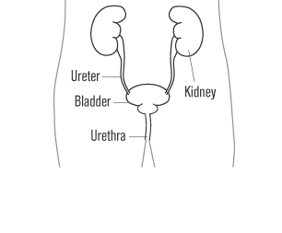
Vertebrates have evolved a different answer to the problem of water balance and nitrogenous waste excretion: the kidneys. The two kidneys filter blood, removing urea in the form of urine, while also regulating the levels of water and salt present in the blood plasma. From each kidney, urine travels through a large duct called the ureter and empties into the urinary bladder. The bladder is a muscular organ that expands to store urine. When the bladder contracts, urine is pushed through another duct called the urethra and out of the body.

The Nephron

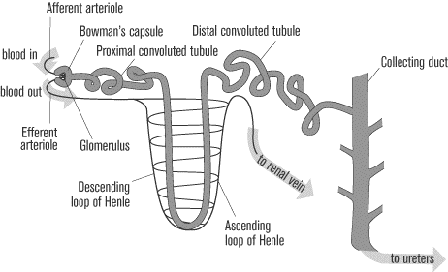
The basic functional unit of the kidney is the nephron, a tiny tubule whose special structure makes it ideal for its blood-filtering task. Each nephron consists of a cluster of capillaries called the glomerulus, which is surrounded by a hollow bulb known as Bowman’s capsule. The Bowman’s capsule leads into a long, convoluted tubule that has four sections: the proximal tubule, the loop of Henle, the distal tubule, and the collecting duct. The collecting ducts empty into the central cavity of the kidney, the renal pelvis, which connects to the ureter, which carries urine to the bladder. A kidney is made up of millions of nephrons.

How a Nephron Filters Blood

Blood enters the kidney through renal arteries, which quickly split into smaller vessels and then branch further into the very narrow clusters of capillaries that make up the glomerulus of the nephron. Because the glomerulus’s capillaries are so narrow, blood pressure is high. The high pressure squeezes the liquid portion of blood through a sieve structure and into the Bowman’s capsule, leaving the blood cells, platelets, and large protein molecules behind. This process is called filtration, and the liquid blood that is pushed through the sieve structure is called filtrate. The filtrate contains large amounts of water, glucose, salts, and amino acids in addition to the urea that is to be excreted.
From Bowman’s capsule the filtrate enters the proximal tubule of the nephron. In the proximal tubule, important molecules for life, such as sodium, water, amino acids, and glucose, are pumped out of the proximal tubule to be reabsorbed by the blood, as they are too valuable to be excreted. The return of these molecules to the blood is called reabsorption. After reabsorption, the filtrate is called urine.
By the time urine enters the next portion of the nephron, the loop of Henle, it has already lost approximately 75 percent of its initial water content and volume. The loop of Henle descends from the outer region of the kidney, the cortex, into the medulla. The walls of the descending loop are permeable to water but not to salt. In addition, the medulla of the kidney contains a high salt concentration, creating a concentration gradient: water is drawn out of the descending loop and into the medulla, leaving the salts behind. By the time the urine reaches the ascending part of the loop of Henle, only 6 percent of the original water content remains. The ascending loop of Henle is impermeable to water, but it is permeable to salt. Because the urine lost so much water content in the descending loop, the salt content at this point is very high. Salt now diffuses from the ascending loop into the medulla of the kidney (helping to maintain the high salt content of medulla). When it is finished traveling through the ascending loop of Henle, only about 4 percent of the original salt content of the filtrate remains. With much of the water gone as well, the urine consists mainly of urea and other waste products at this point.
The urine then enters the distal tubule, which operates very similarly to the proximal tubule—salt is pumped out of the urine, and water follows osmotically. By the end of the distal tubule, only 3 percent of the original water content remains in the urine, and the salt content is negligible. In the distal tubules, a third process, in addition to filtration and reabsorption, takes place: secretion. While the salts and water are leaving the tubules, some substances, such as hydrogen and potassium ions, are actively transported from the blood into the urine of the tubule so that they can be excreted from the body.
From the distal tubule, the urine enters the collecting duct. Like the loop of Henle, the collecting duct extends deep into the medulla portion of the kidney. Because the medulla has a high salt content, as much as three-fourths of the remaining water can be reabsorbed as the urine travels through the collecting duct. The actual amount of water that is reabsorbed is dependent on the permeability of the walls of the duct, which is regulated by the antidiuretic hormone (ADH) secreted by the posterior pituitary gland. ADH acts on the walls of the collecting ducts to make them more permeable to water, but if ADH levels are low, less water will be reabsorbed. If a person is dehydrated and needs to conserve water, his or her levels of ADH will rise. In contrast, a person with sufficient levels of water in the blood will have low ADH levels, resulting in less reabsorbed water and more dilute urine. In addition to being permeable to water, the lower portions of the collecting duct are permeable to urea, allowing some of it to enter the medulla of the kidney. This release of urea allows the medulla to maintain its high ion concentration, an important factor in the functioning of the nephron.
Another hormone that has an effect on the nephron in addition to ADH is aldosterone, which is produced in the adrenal cortex. Aldosterone increases the sodium and water reabsorption in the distal tubule.

The Kidneys and Blood Pressure

In addition to controlling the amount of water that is reabsorbed from the filtrate, which has an effect on blood volume and blood pressure, the kidneys release an enzyme, renin, into the blood. Renin sets off a series of reactions in the blood that results in the production of another enzyme, angiotensin II. Angiotensin II constricts blood vessels, causing a rise in blood pressure. It also causes the adrenal cortex to release more aldosterone, which raises blood volume and blood pressure.

